File > new > project> Asp.net application MVC

Architectural patter divided into 3 part

Model: supplied data and business login

View: deals with presentation basically rendering of the data.

Controller: Heart of mvc act as coordinator between model and view.

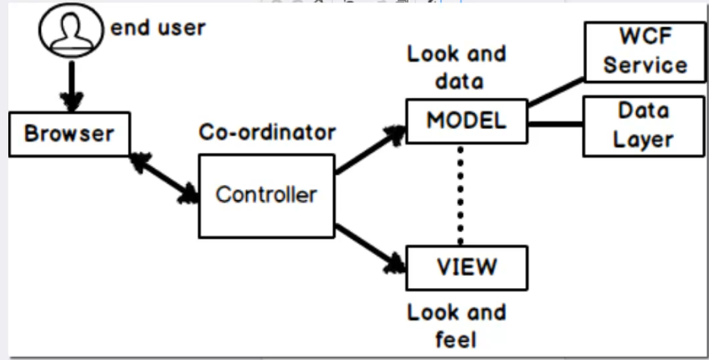

When user request for resources ultimately request comes to the Controller which basically fetched the data from the model and send t to the view

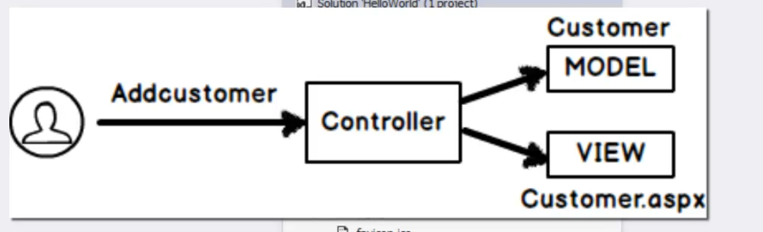

Each layer is associated with its own functionality so changes done to one layer will not effect the other layer they are completely independent of each other

Don’t delete controller word while making new controller.

For every controller created a folder created inside view folder to make all views related to that controller.

Controller will do some manipulation and return the view to be rendered on the screen.

Inside the view folder we have shared folder

Folder name Specific to the controller

So the view can be present in any of these folder

If the name of action method and view is different then we have use name of the view along with the view returned from the action method.

If the name of vie and controller action is same then just use return statement to return view.

Shared folder in views folder basically contains list of all the view.

**Routing in mVC:**

Simplifies the mv curls

Maps view url to our controller and action methods defined

Basically we can define user friendly url for the view

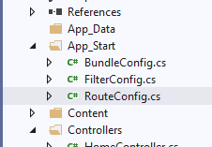

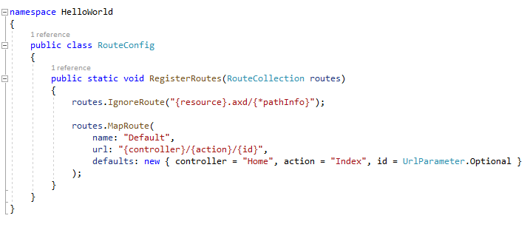

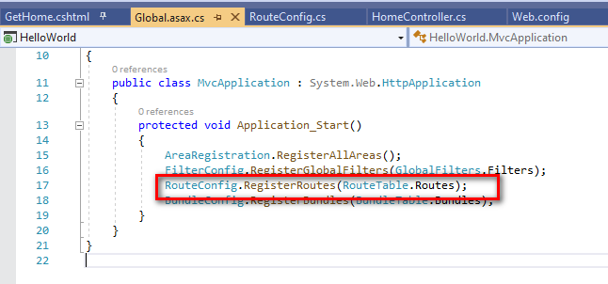

Techniques to pass data to a view:

No code behind

No view states

No server control.

1. Viewdata/viewbag
2. Tempdata
3. Session variable.

View data/view bag: to pass data from the controller to the view or action to view

Scrip tic syntax: ViewData[“key word”]= value;

View bag is syntactic sugar on top of view data

ViewBag.MyTime = DateTime.now;

Viewdata or View bag maintains only data between the action to view

It will not maintain between the controller to controller or action to action.

So to maintain data between controller to controller

Or action to action we use Temdata

Just maintain data between controller to view used viewdata

To maintain data to entire request between controller to controller and then from action to view uses temp data.

View bag is collection of view data.

View bag scope: between controller and view

Temp data scope : between a full request cycle (c ->c->c----🡪 v)

Session variable scope: value will be maintained until the session is active.

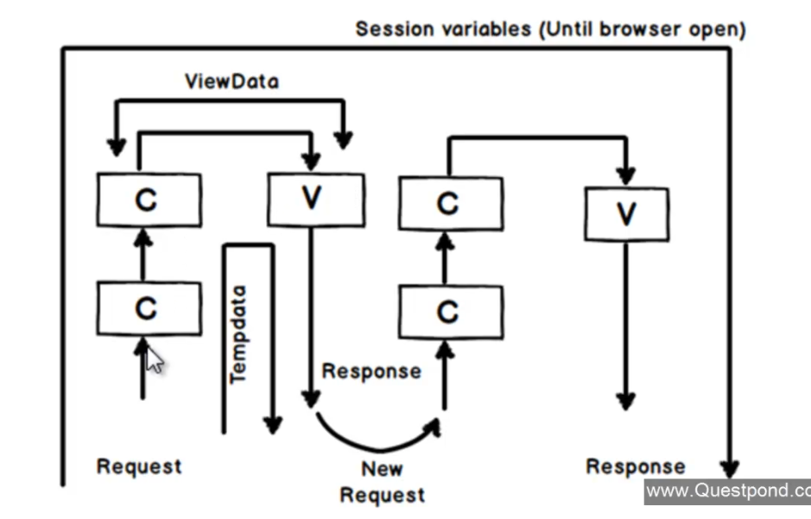

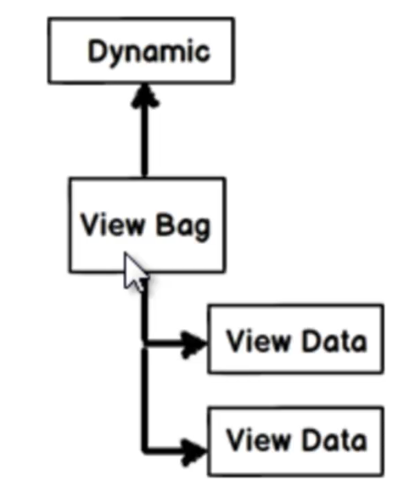

Redirect call from one action to another action:

return RedirectToAction(“Action name”,”Controller name”);

Model & strongly typed views:

Model is responsible for the data and business logic associated with the data.

View connected to model with data binding is called the strongly typed view

So while making model

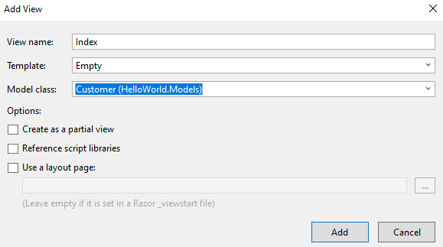

Model binders:

Automatic binding for this model property and form fields name should match with each other.

What if the model field name and the form control names are different?

In such scenarios we need to used model binders as attribute on top of the model object bound to the controller action method

Interface iModeBinder > method BindModel

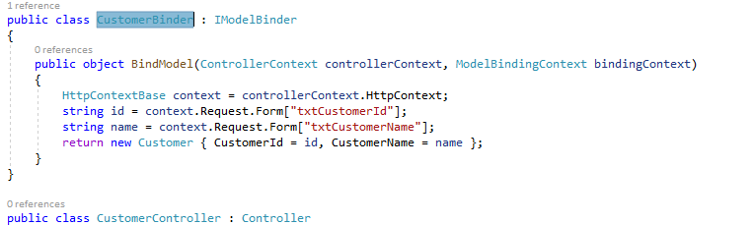

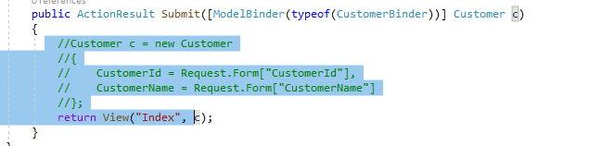

Why MVC:

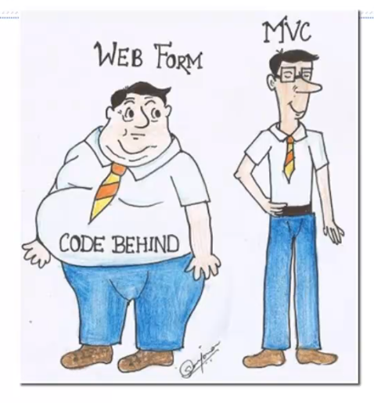

1. View based architecture, web action based architecture

2. Behind code is reusable for different view types (mobile, web etc)

3. Fixed response type in web

3. flexible view and data Control which type of data to be returned or which view can be used for the rendering

4. testing is easier because the things are loosely coupled.

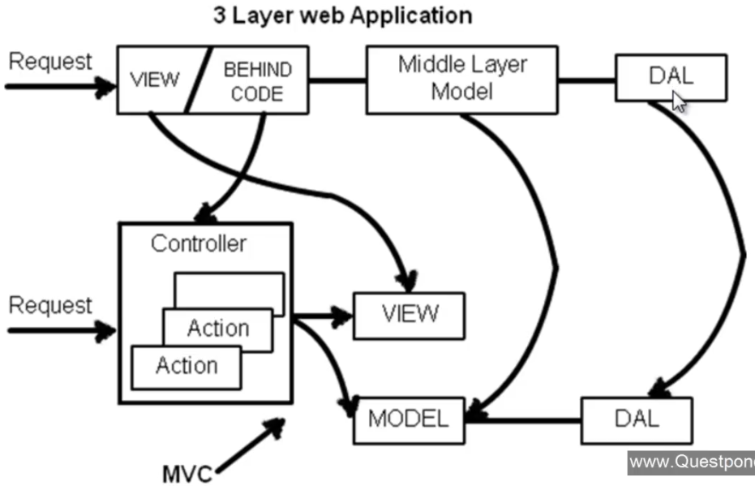

MVC

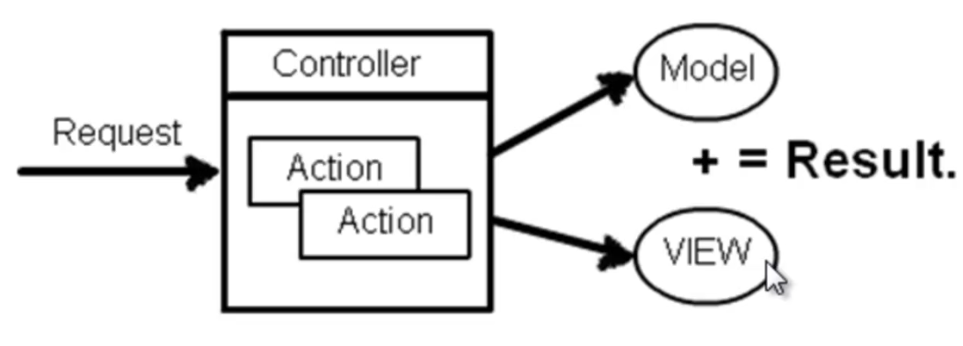

Temp data keep and peek:

Temp data can be preserved between multiple request

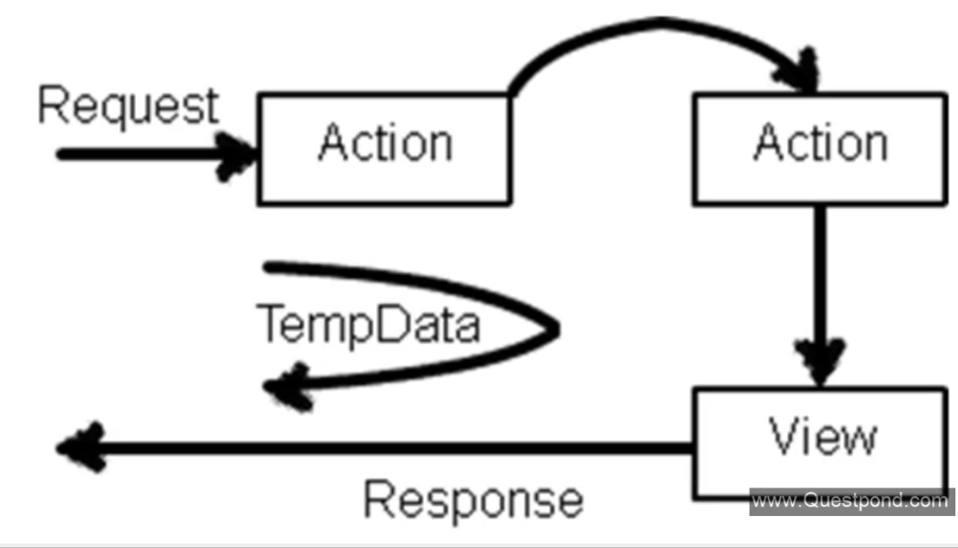

1. If the value is not read from the temp data value will persist
2. If the temp data value is read the value will be cleared or lost
3. If you run keep method on the temp data after reading its value the data will persist.
4. Read value using peek method it will persist the value.

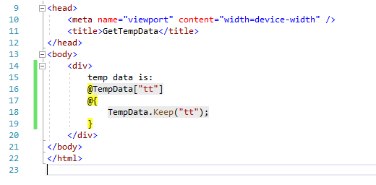

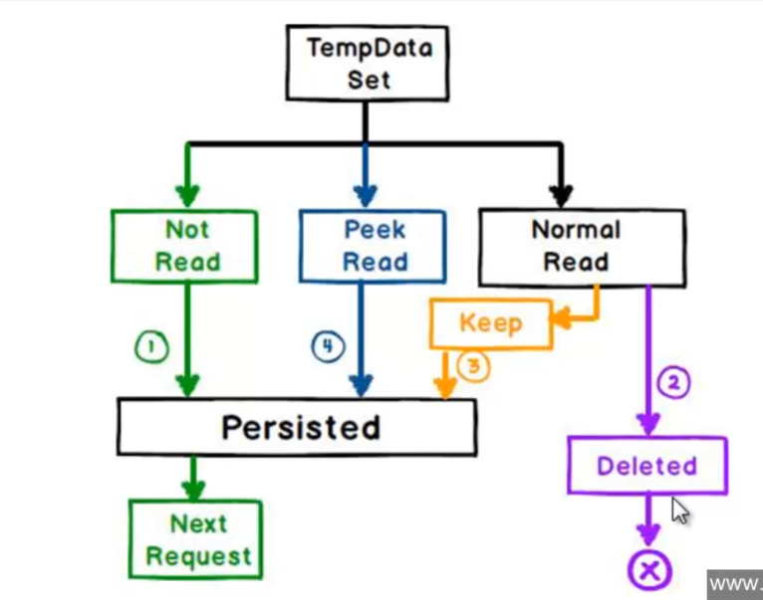

Data annotation and helper class:

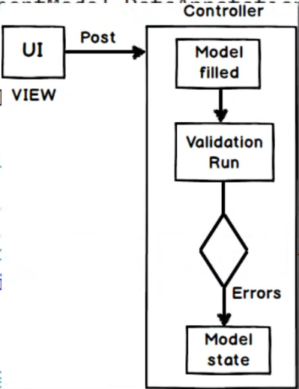

With data annotation its possible to setup the attributes and constraints on top of the class fields.

Help class are nothing but the class help in achieving some on the view components

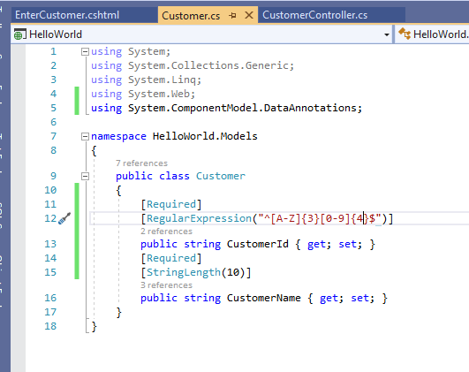

Decorated with constraints

App setting:

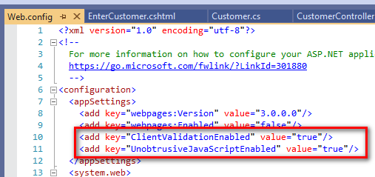

Helper class to display validation summery

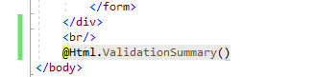

On model binding of the controller action method validation will be done and ModleState class will be set.

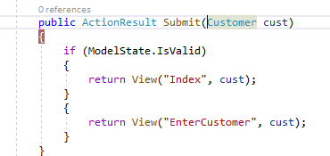

Instead of displaying the error message in on section how about displaying after each and every control.

@Html.ValidationMessageFor(r => r.CustomerId)

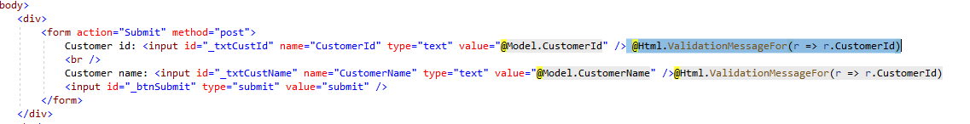

This type of validation will make a round trip to the server in order to perform the validation

Enable jquery to do a validation on the client side.

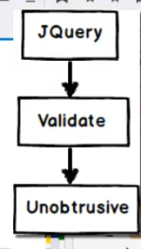

Steps:

1. Include jquery files in he above mentioned order 3 files.
2. Replace form tag with html helper tag for form
3. Replace input controls with equivalent helpers.

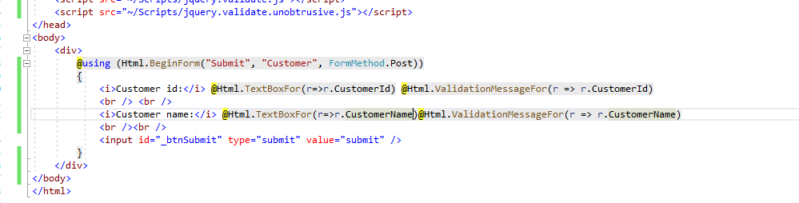

View Model:

Sequence diagram for mvc:

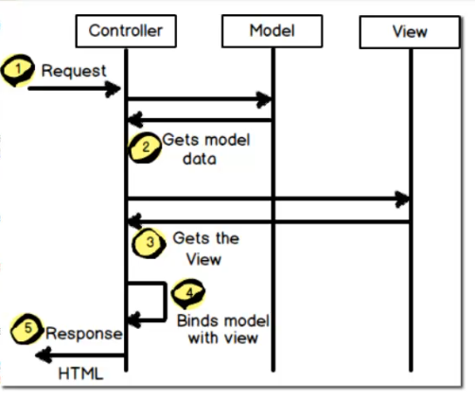

1. Make strongly typed view of multiple models
2. Data transformation logic
3. Presentation logic

Define a custom class which has the logic of presentation and transformation and the combination of multiple entitiy.

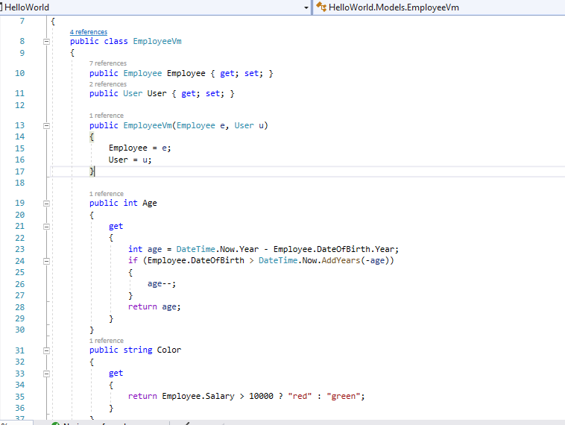

Entity frame work in mvc

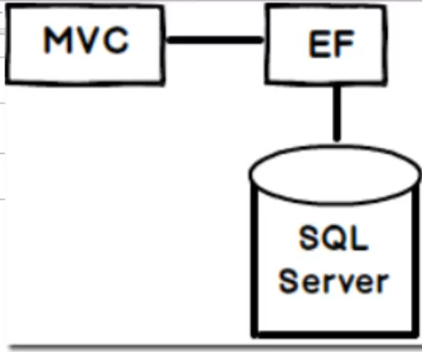

For code first approach:

1.Define db and the entity file

2. Add connection string in the webconfig file

3. mapping between entity and the table done

1. With the help of table attribute

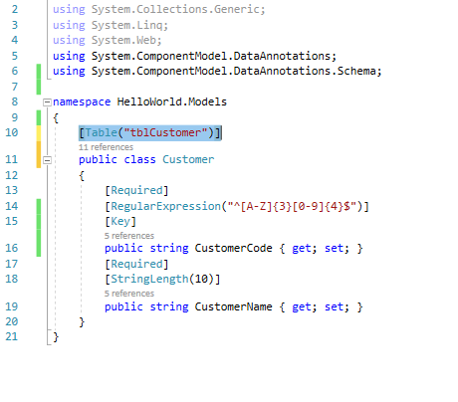

2. Override event in Db context file.

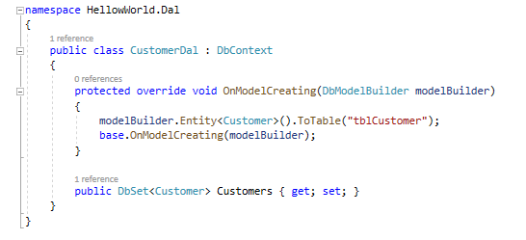

View model & Partial view & Grids

View model is basically used to club multiple entity in a single class file so that binding of the model to the view becomes easier

Eg: Customer application when in I have to add new customer display the list and search the customers.

Here we need to add a model view class with list, criteria and single customer object

Partial views:

Reusable view used in the system similar to web used controls.

We use html helper class called HTML.Partial(“view name”, model);

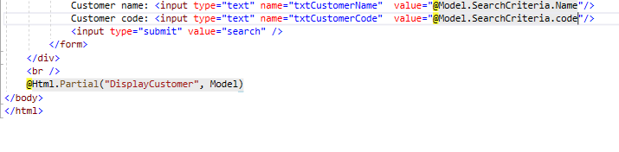

Web grid built in control to build grid

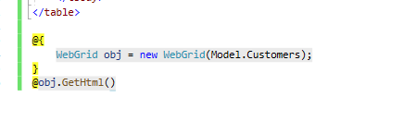

Action results and view results:

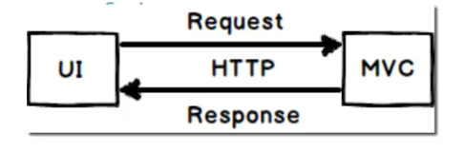

Both are class representing the result nothing but response comes from the controller actions

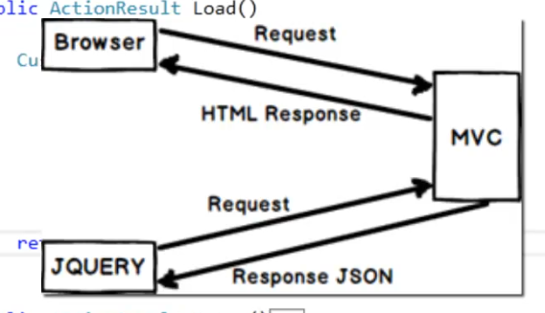

ActionResult is apparent base class for all the result returned from the action method So we can return any type of the data out of it

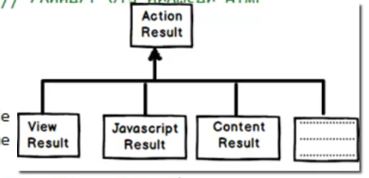

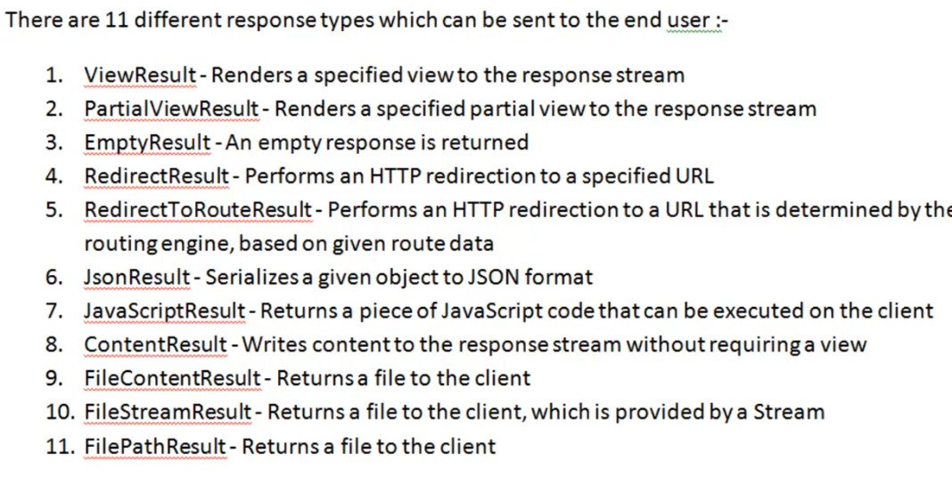

Ajax using Json jquery

Asynchronous javascript and XML

It will does asynchronous processing and sends and gets only the necessary data

Ajax call for getting the data

$.get(‘Action name’, null, success method)

Function Success(data)

{

}

Ajax post call:

$.post(‘Action’, $(‘form’).serailize(), success method)

Asynchronous controller in mVC

IIS has thread pool which basically servers the request comes from the user

With this we make a controller aynch so that there wont be any thread starvation problem.

4 steps to do it

1. Your controller must implement AsynController base class
2. Controller action must be mark as Async
3. Controller must return task action result Task<Actionresult>
4. Add await to the long running process.

Authentication and authorization.

Authentication: if the user is exist in data base or not

Authorization : check if the user has access to use then section of the page.

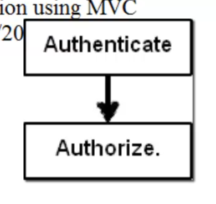

Authentication:

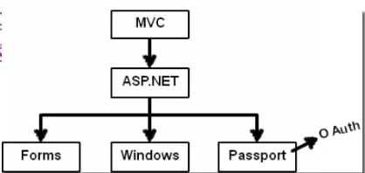

For windows authentication users need to be saved in the local windows machine or ADS active directory services

Normally used for the internet based application. Where all the credentials saved in the server and access using windows services.

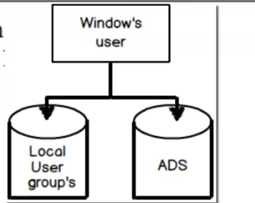

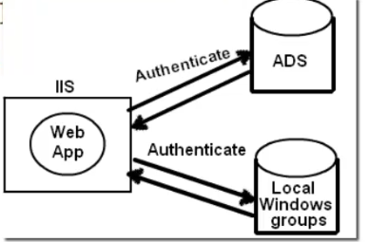

Windows authentication:

Steps:

1. Enable windows authentication from Web config
2. Authorization to deny anonymous user.

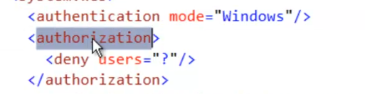

Add authorize attribute on top of the controller class

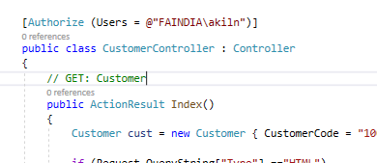

Forms Authentication:

1. Add user table
2. Web config setting.

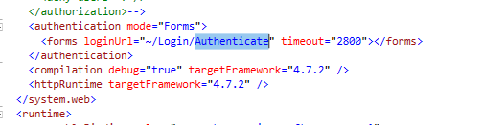

1. Decorate controller with

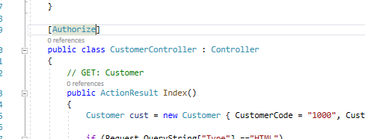

1. Provide authentication details.
2. Validate
3. Set authentication cookie

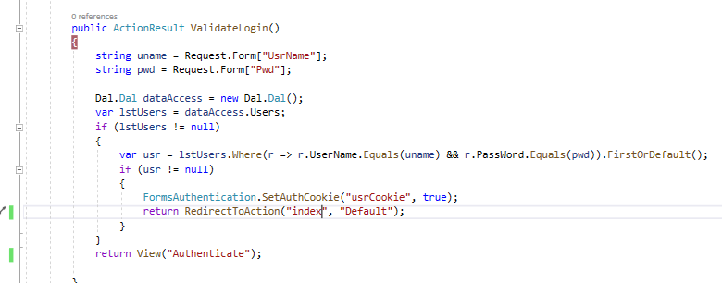

Areas in mVc

Modular development

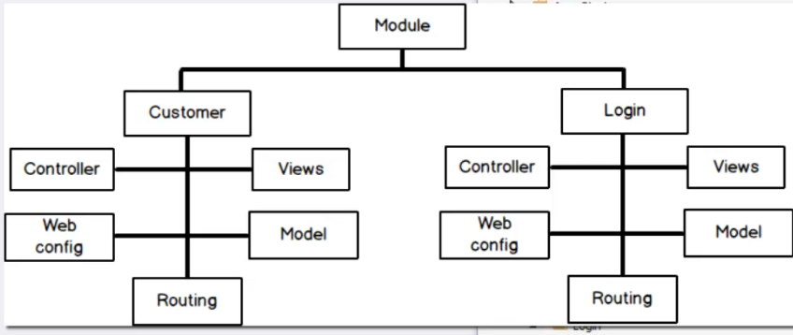

For creating new area

Right click on the project and create area

Area has its own views controller, model, configuration file and route registration

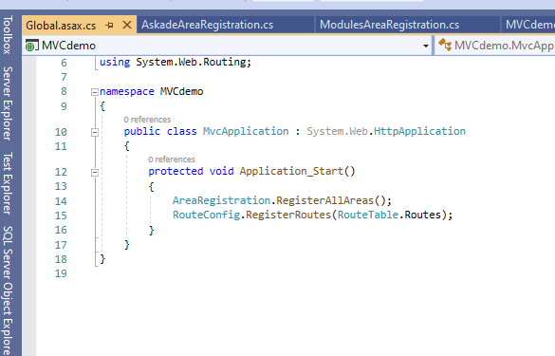

Area registration:

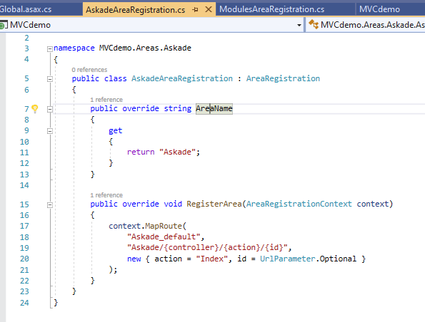

Angular and MVC 5

Can we Overload the controller action methods:

Yes and partially no

Because C# supports overloading of methods

But in MVC controller action method forma the end point for the url and HTTP expect every url to be unique

So this can be achieved with the help of the ActionName attribute on top of the controls action method.

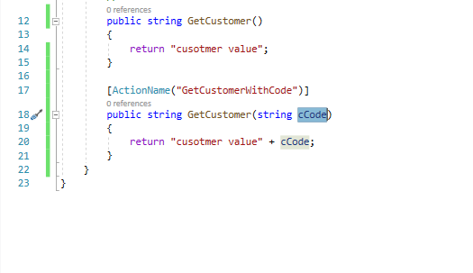

Web Api

Respects HTTp protocol and uses the rest architecture.

Current architecture.

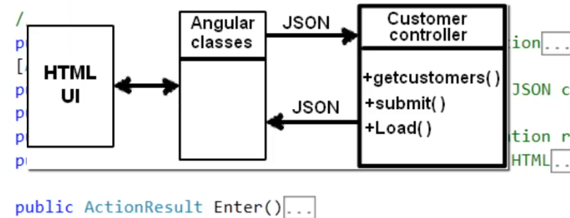

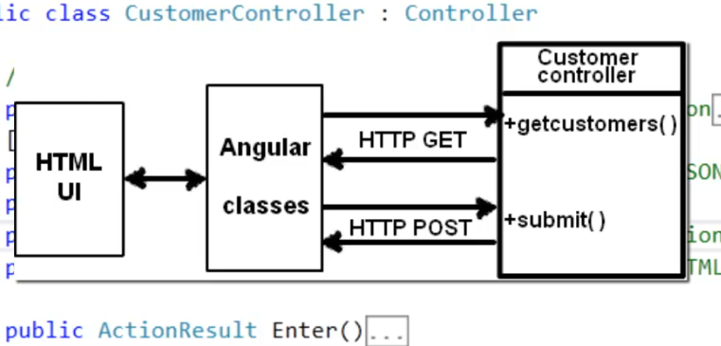

Rest:

Both client and server respects the HTTP way of communication so it simplifies the implementation between them this stand for representation state transfer

Exception handling in MVC

1. Use try catch block

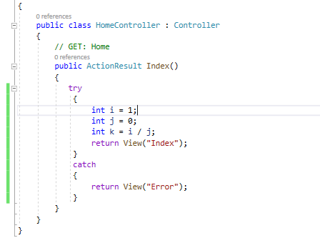

Problem violation on dry principle (do not repeat yourself) . This implementation will repeated the exception handling logic in all the controller action methods.

1. OnException method from the controller class

Here you need to create view result and assign it to exception action result

And set filter exception handled property to true to indicate exception is handled indicating that no default behaviour in needed

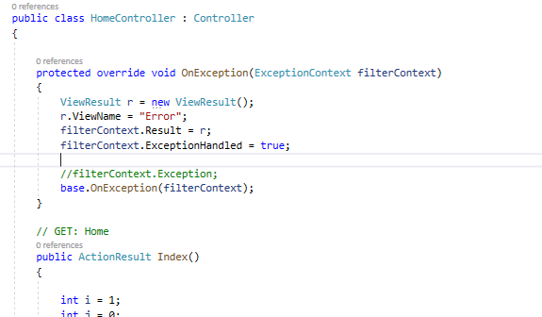

Problem specific to the controller exception handling login cannot be shared with other controllers.

1. Inheritance make base class implementing controller and implement the OnException method in base class and the implement all controller from the base controller.

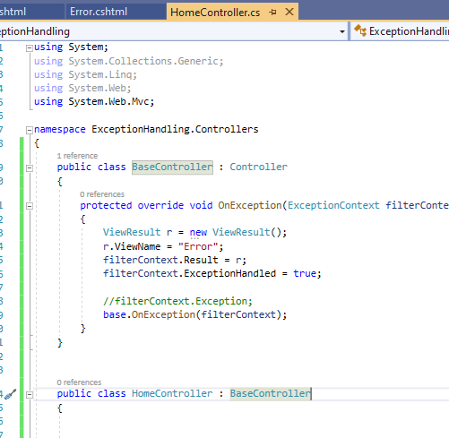

Problem customization where in different controller want to customer the exception handling logic.

1. Exception filter for the controller or action

Steps:

1. Enable custom error from webconfig

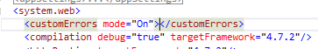

1. Create Error.cshtml view in shared or controller view folder

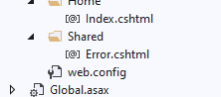

1. Decorate controller or action method with HandelError Attribute

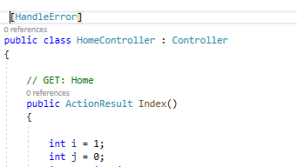

But for this we need to add this attribute for each and every controller we can avoid this by registering the error handling at the global level

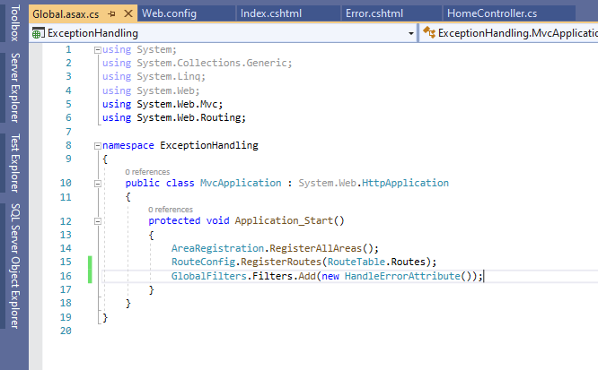

Say you need to display the information about he exception

Then make your view as strongly typed view for the class type ‘HandleErrorInfo’

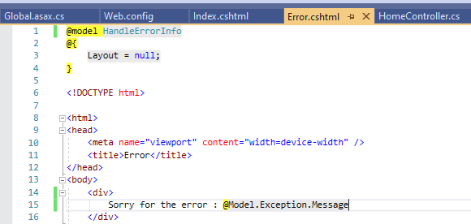

Say you want t0 render a different view for different error

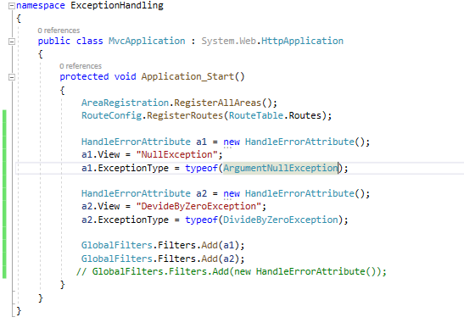

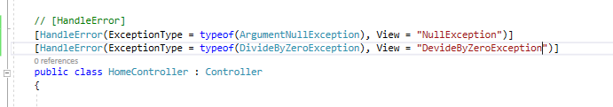

In above approach if you want to perform the logging on exception the it is not possible so to support this we need to have some custom exception filter class.

WebGrid: helper function present inside the MVC library

Make view model

The model specific to the view

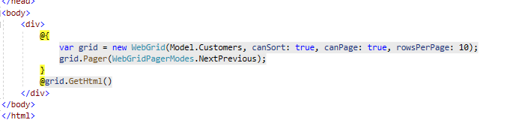

Single page application WITH MVC

Building application using one page

Here im using a promising object $.get() to get the action result\

Promising objects basically tells on completing of the execution it will return something for the use.

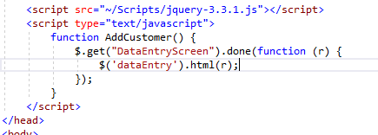

Mvc Ajax for the ajax call

Install this package to the solution

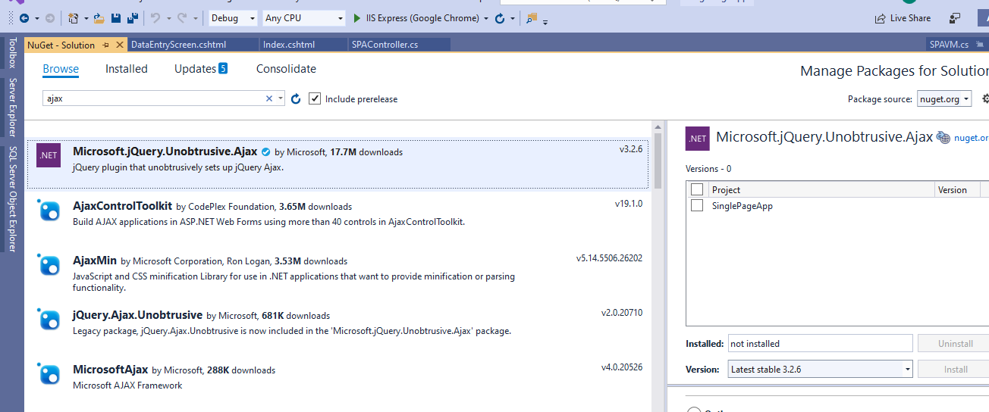

Includes this jQuery file

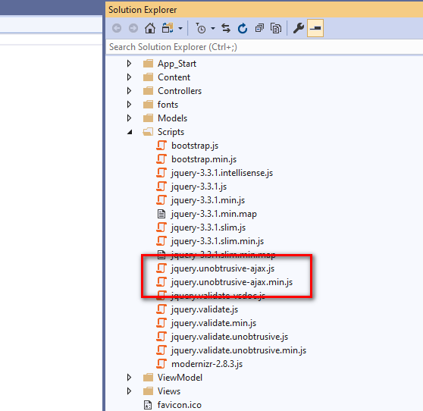

Then use the Ajax for tag to perform MVC ajax call

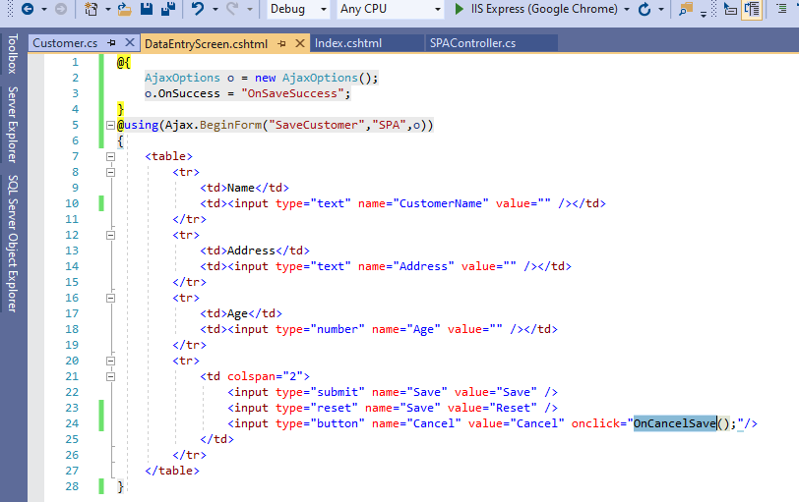

Organize MVC project and understanding cross domain issue.

Add separate projects for the

Model

Data access layer

Ui

Web Api

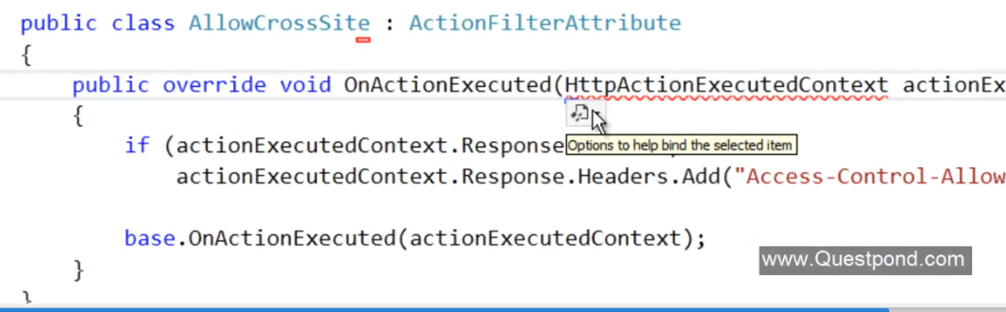

When web api and the ui hosted on different domain we get a cross domain issue. So to fix this we need to add the Action filter attribute on top of the controller to allow access to the Api.

Access-control-Allow-Origin header value to be sent with reponse

Display modes:

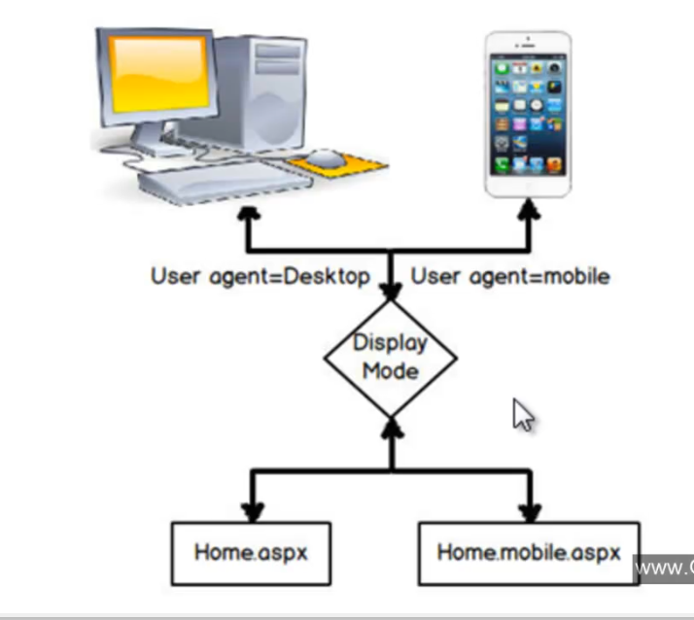

Based on the device its possible to have the separate view for the device

For that we need to create separate views

Index.cshtml

Index.Mobile.cshtml

We can also have the custom views based on the os. Say for android I want to have a separate views.

Then

For this first we need to add display mode providers which is defined under

System.web.webpage;

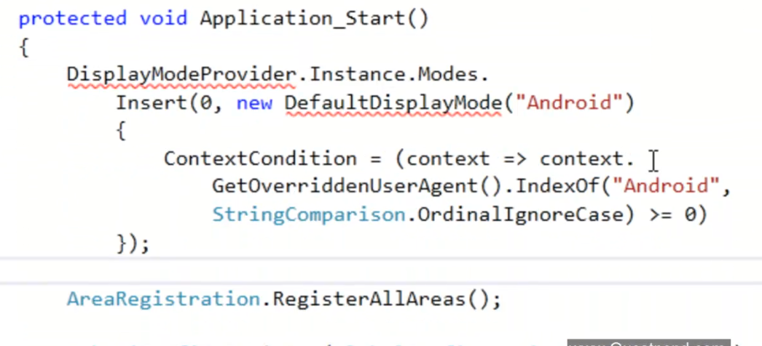Then add

Index.Android.Cshtml add this view

Unit testing in MVC

Testing the code (every unit of the code we test) in automated and isolated mode is repetitive manner

In MVC we can test models

Data access layer

Left out Is controller. That mainly perform this job received the request from the view. Generate data and send it back to the view.

1. Test if the proper view or not
2. Proper model/viewbag/viedata
3. Proper redirect to view

Testing the redirection result:

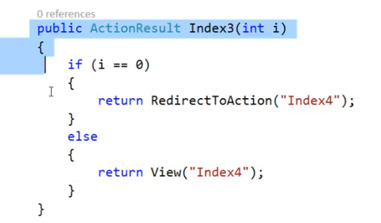

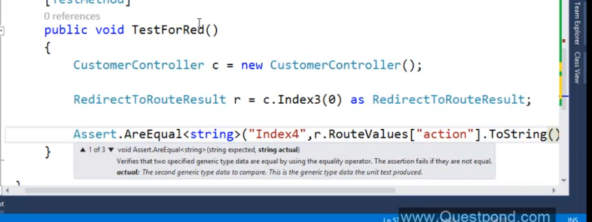

Multiple submit in form:

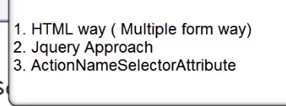

1. **HTML way of solving problem add separate form tab for each buttons.**

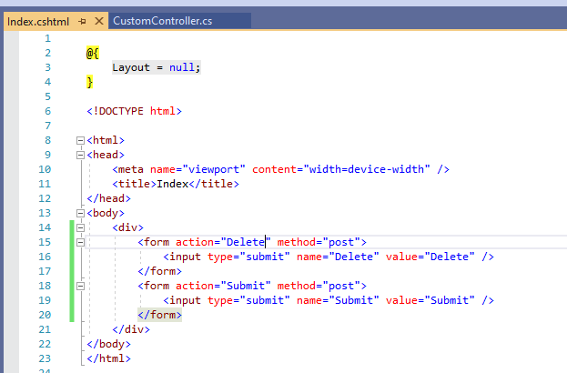

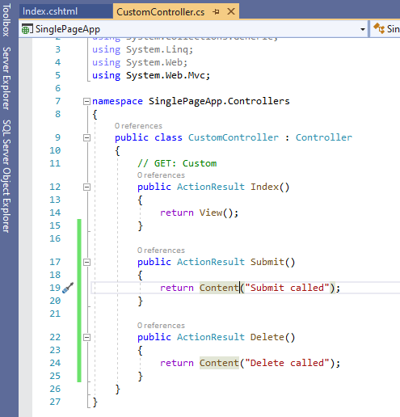

**2.JQuery solutions:**

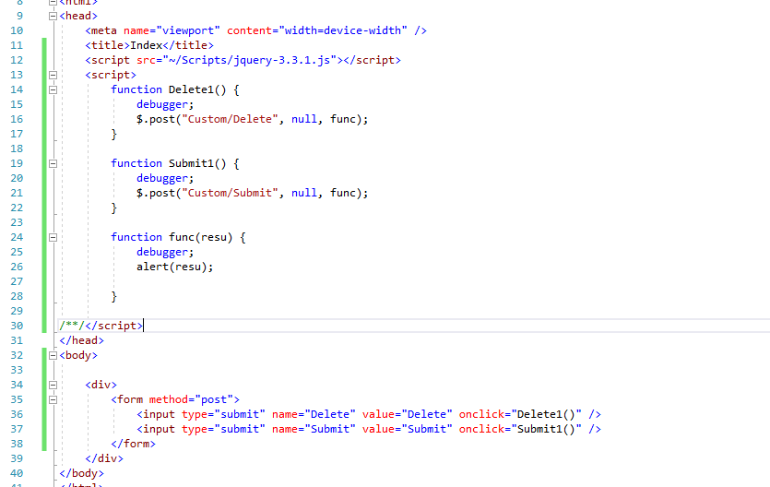

1. Use Action Name Selector Attribute

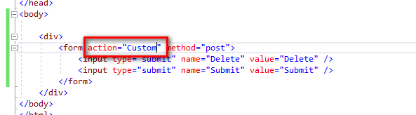

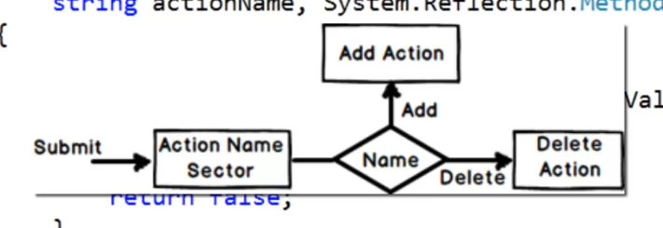

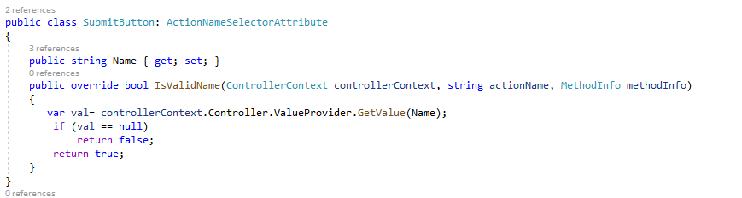

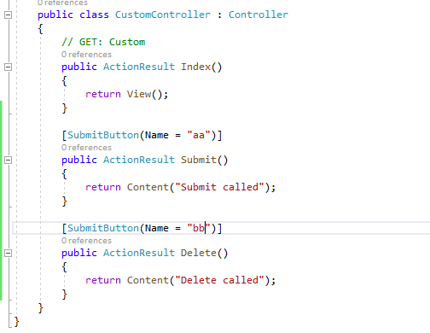

Antiforgery token:

Basically used to avoid the deadly attack called CSRF (Cross Site Request forgery). Method of hacking system where in he acts like trusted system.

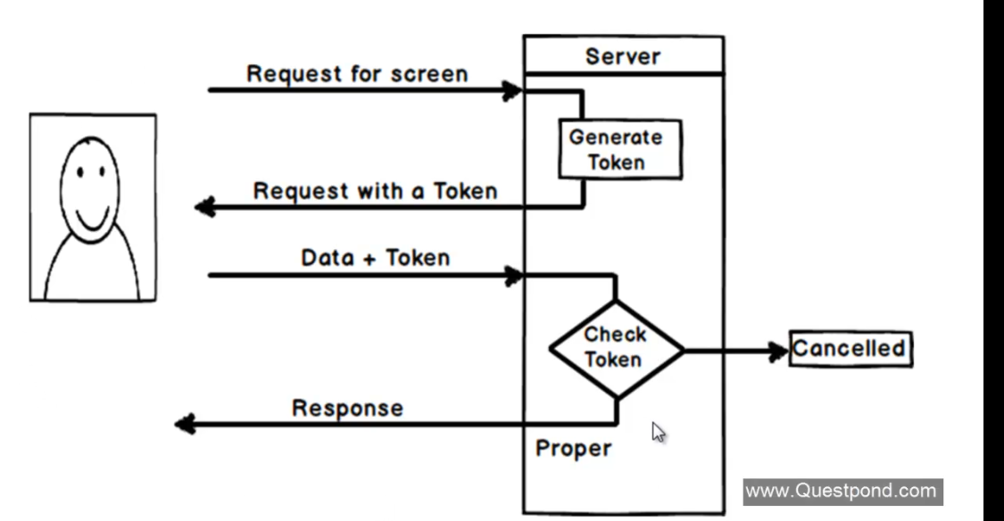

CSRF: cross site request forgery:

Hacking method by which the requesting client forges to be the trusted client and get access to the system

This can be eliminated with the request token sent as a part of the request generated by the server called antiforgery token

Html helper used:

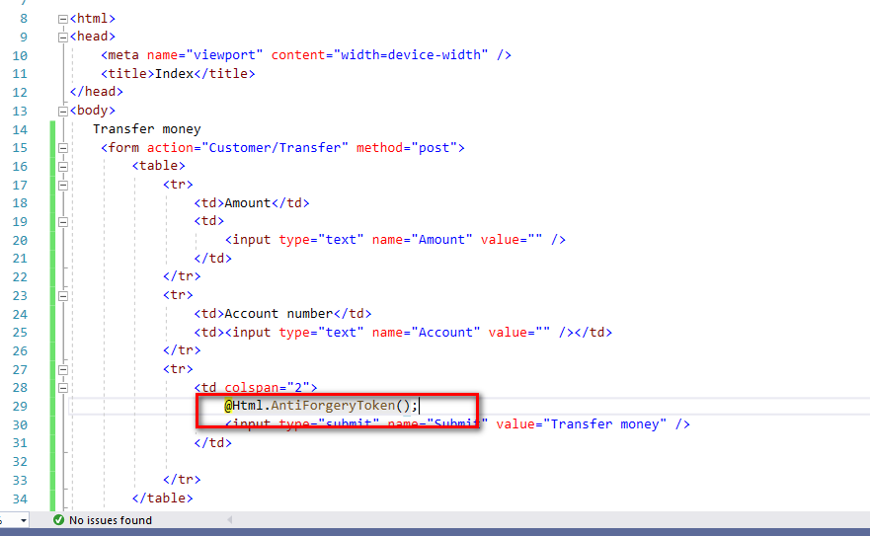

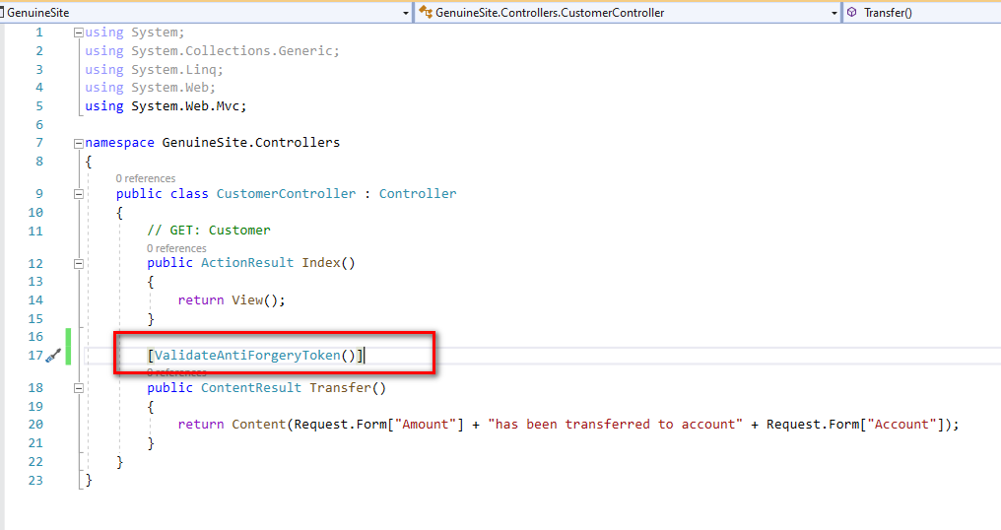

From the forged site you get

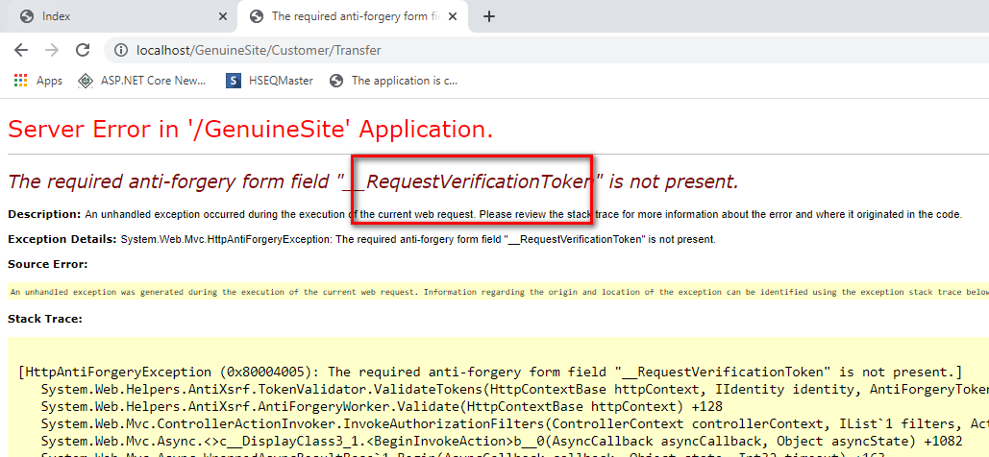

Forged client my also generate the antiforgery token so use salt value to eliminate.

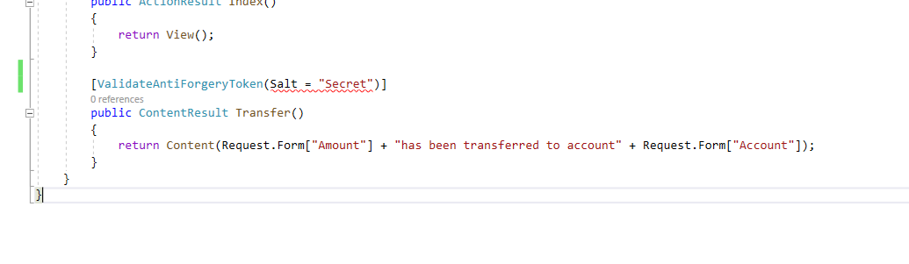

Input validation:

Validate input allow Html

XSS – cross site scripting issue. Script attacking to the application where In the hacker will inject malicious script to the application as a part of input.

Validate input on the action method level

AllowHtml is on the property level.

By default input security is enabled. It will throw and error if in valid html is entered.

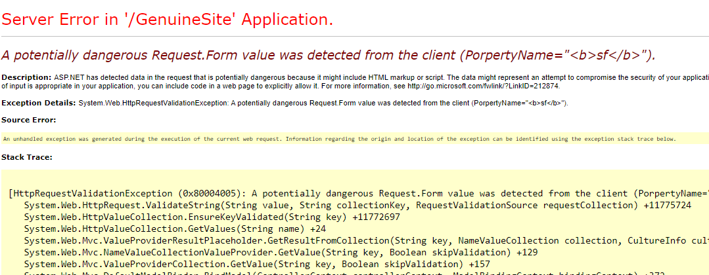

Disable input validation for entire action method. Which will open up security issue. And application is more prone for the XSS.

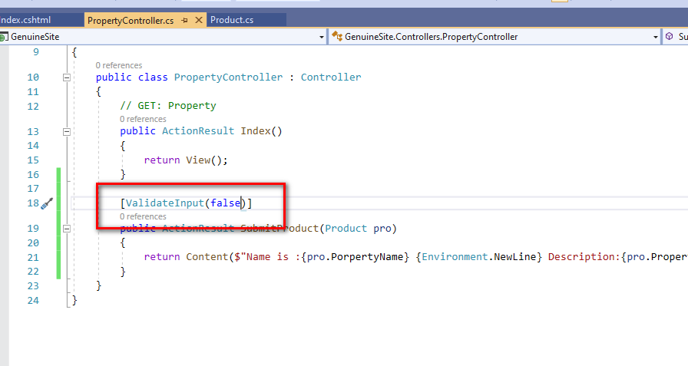

Suppose you want to allow html only for the particular field and not for entire form.

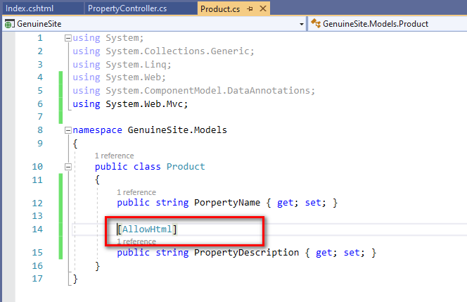

Bundling and minification:

Increase the performance of the application

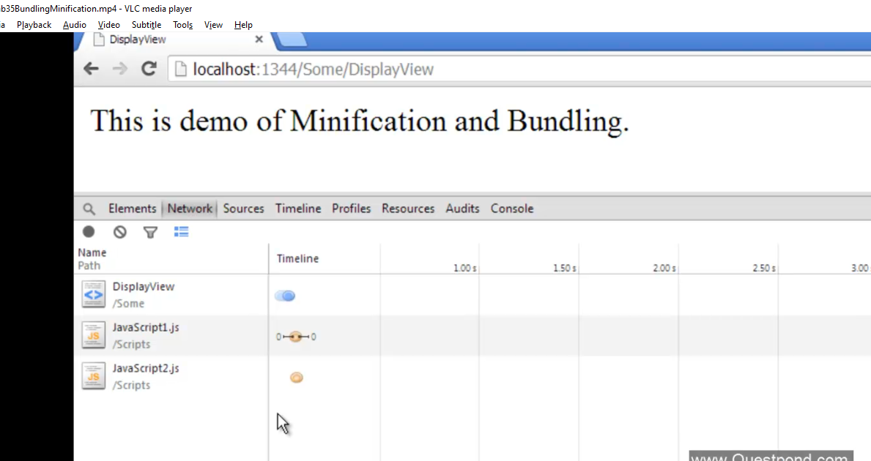

Say application has multiple css files and javascript file . we make a call to a page that uses this css and JavaSript. So depending on number of css files and jquery file our browser will make so many calls to the server or so many get requests to the server.

SO with bundling we make number of CSS and javascript files into single entity and during runtime we use single call to download this single entity.

So all multiple request will be eliminated and with single call we can get all the files.

System.web.optimization namespace to do this

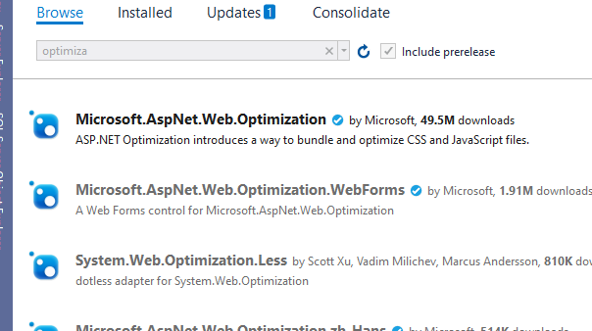

Above name space is responsible for the bundling in .net

Then we need to implement the BundleConfig.cs file in the project

Minification

Will reduce the size of the Css, script file by removing all the comment, white space, new line characters.

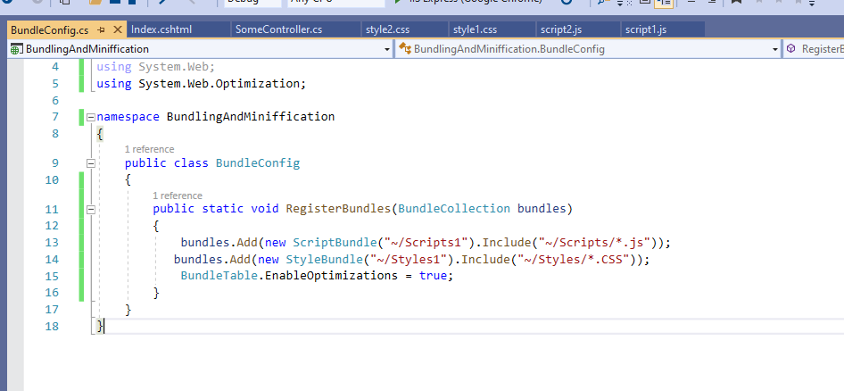

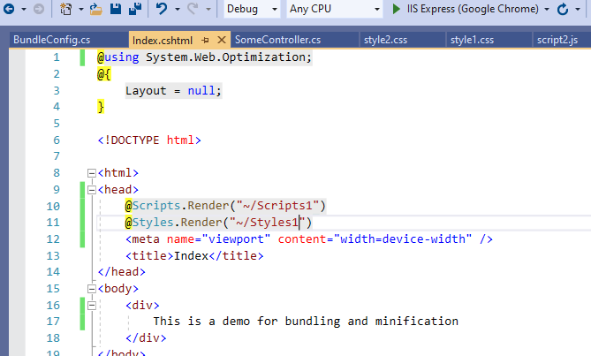

Layout pages in MVC:

With this we can achieve consistent look and feel across the application. Header, footer, logo etc

Its also type of view

Similar to what we have in master page

With this we can have the shared design or html for our application

Define Html layout at one and use it across all the views

Add shared folder inside views

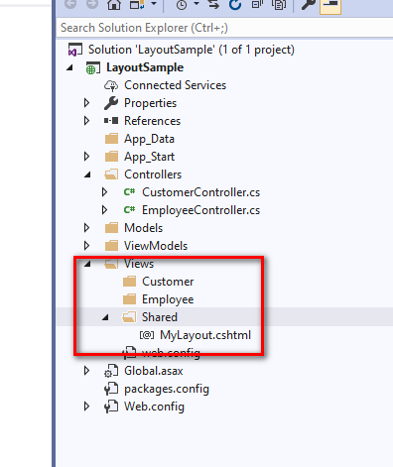

Things put inside the shared folder can be shared by all the controllers

Then Add layout related html common for all page

Then call body render method @RenderBody() this will render the body content from the

Suppose we want to render any section of the content from view to master screen then we can have name section. And define that section in view

@RenderSection(“Section name”);

@section desction name{define content to be rendered}

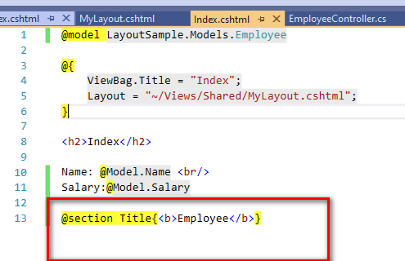

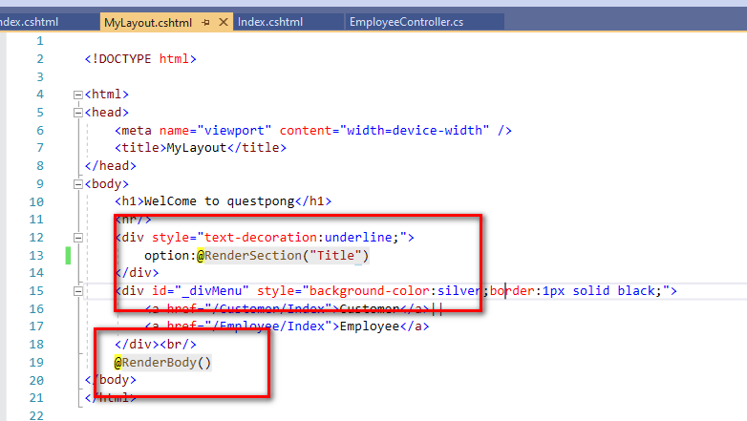

Action Filter:

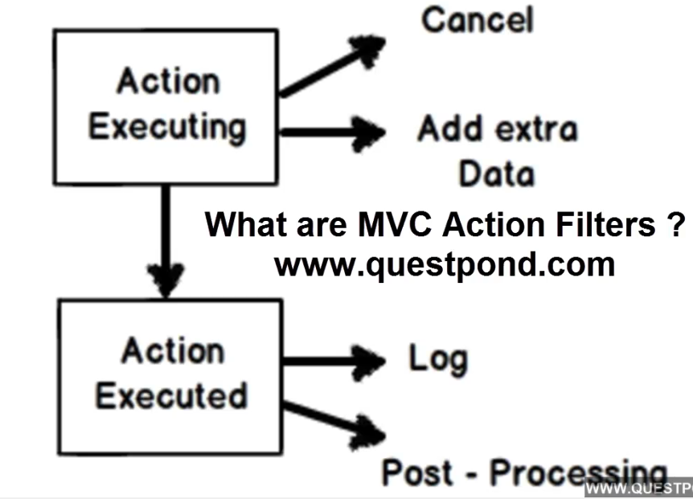

With this we can inject a logic before and after the execution of the action methos logic

Inline action filter:

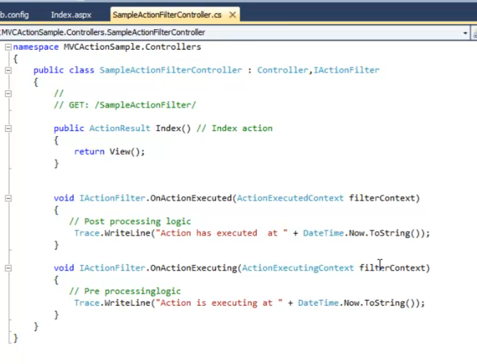

Asp.net Web API

Old : WCF and web services use soap object to tunnel the data using HTTP as protocol in their transport layer.

transfer data in XML format

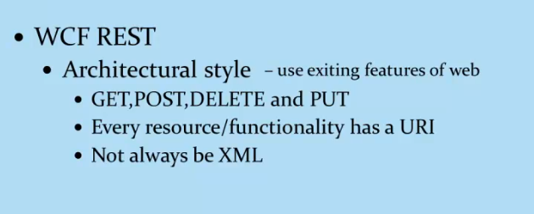

Technology to implement the restfull Apis.

Here we have APi controller and methods inside it are HTTP Action methods that are HTTP methods

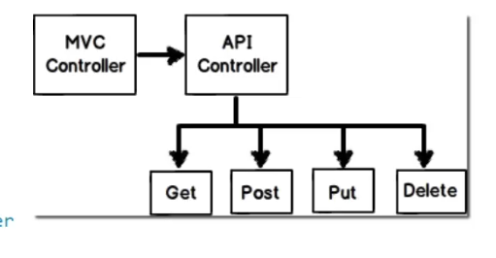

We use Api prefix in url this is because we want to segregate MVC routs from webApi routs

BY Mosh Hamadani:

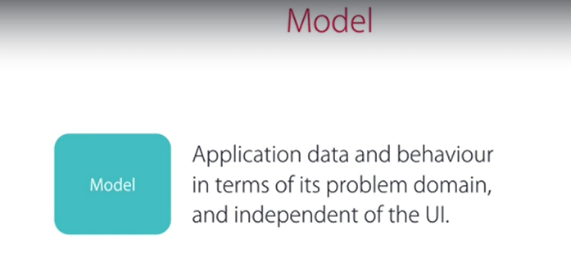

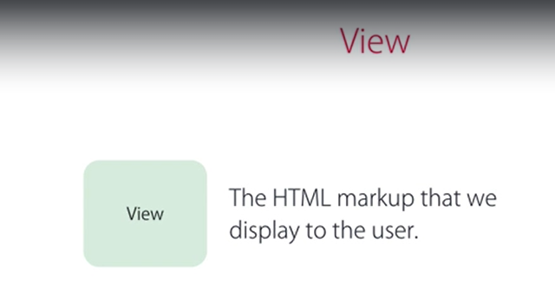

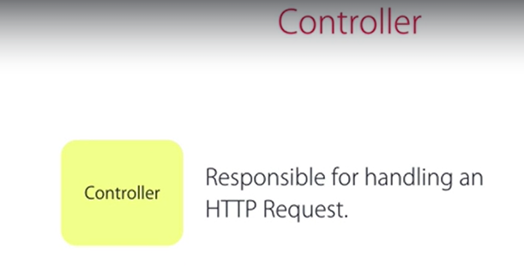

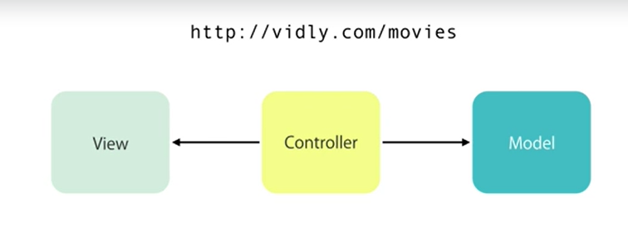

Responsible for selecting right controller and action

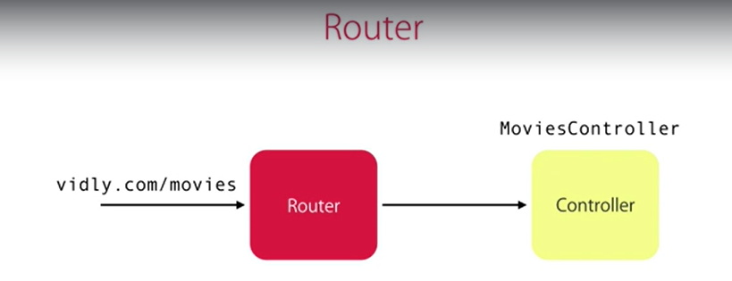

Asp.net MVC by default uses the Boot strap as UI framework

So we can change the application them as follows.

Load:

<https://bootswatch.com/>

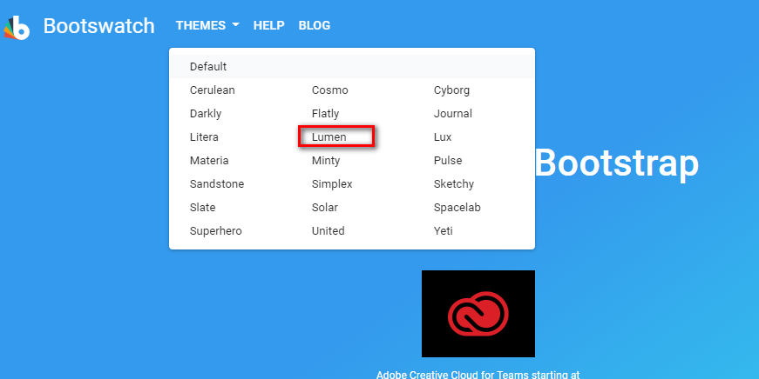

Download

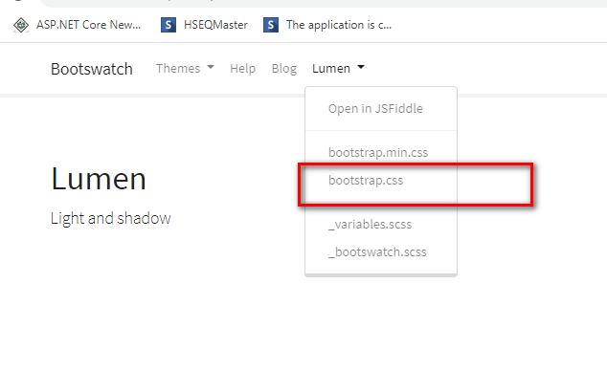

Include the downloaded Css in project with theme name

Add this in bundle.cs file

Acton result:

Base class for all result returned front eh action method

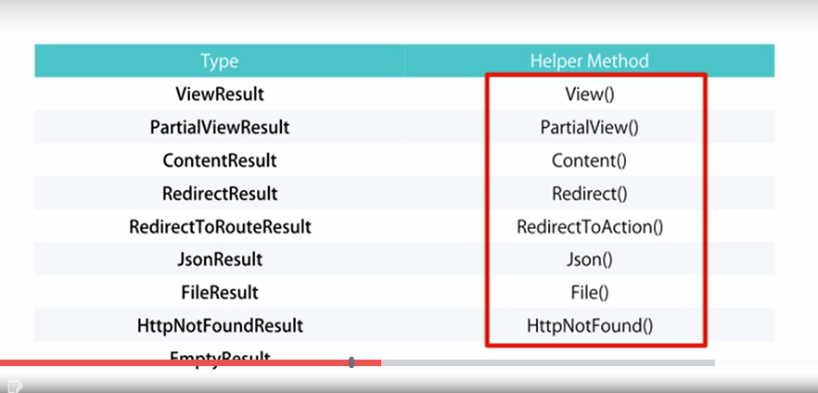

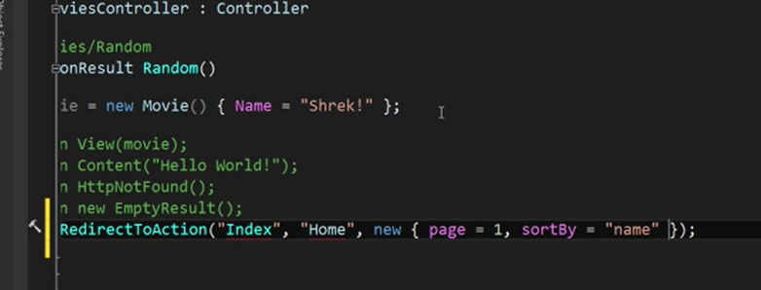

Action parameter:

Basically passing parameters from the url to action methods

Either we can integrate it as a part of url or as a query string parameter to the URL

Integrated in URL

<http://Appname/Controller/ActionName/parameter>

As query string parameter

<Http://Appname/Controller/Action?prameter1&Parameter2>

**Convention based routing:**

Custom routes can be defined in the rout config files where in I have to add the custom route in the beginning and the put the generic routs.

So the ordering should be always from custom to more generic.

In url patter {} indicates the place holders

Attribute routing:

Add rout on top action method and enable attribute routing in rout config

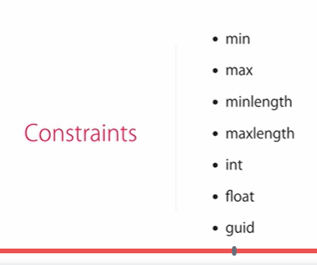

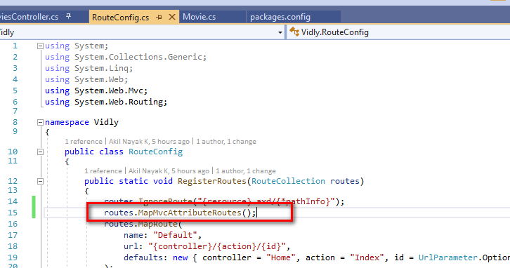

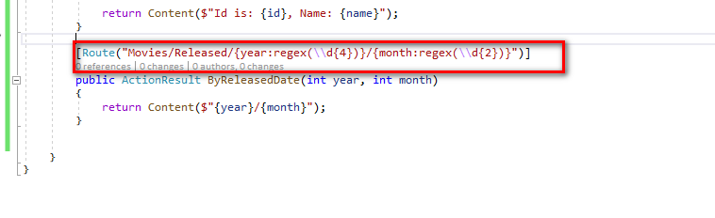

Passing data to the view:

ViewData dictionary

ViewBags

View models: Models built specifically for the view basically contains all the data specific to that view. Gets data from multiple models and bound to the view.

Partial views:

By convention partial view always prefix with (_ (underscore)).

Similar to user controls which we have in asp.net with which we can reuse the controls across different module or the screens.

Create view with partial option selected

Render the partial view:

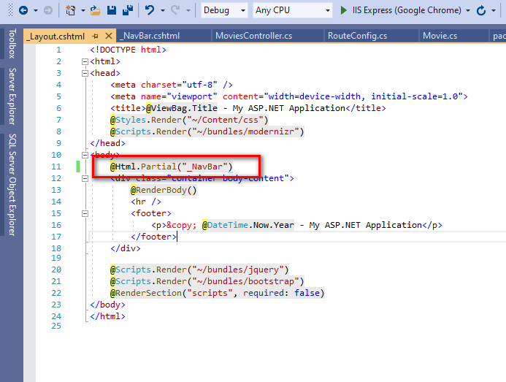

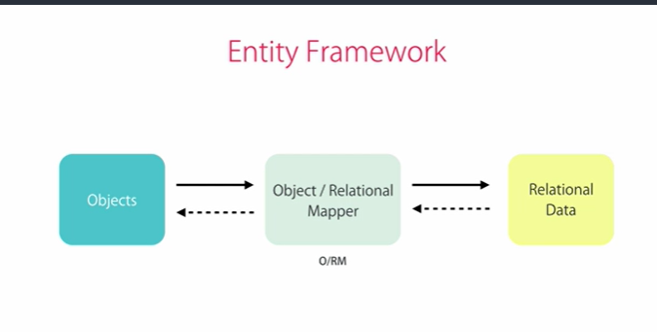

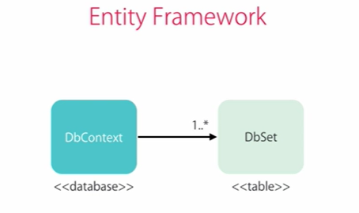

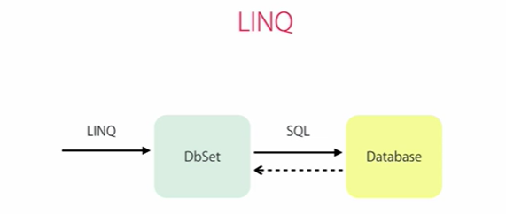

DB first vs Code first approach:

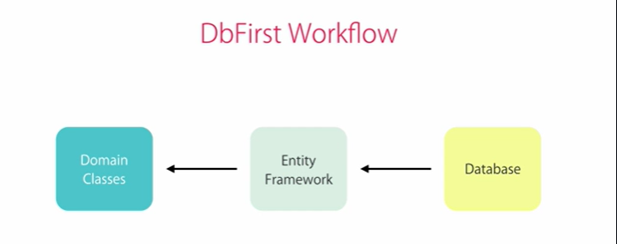

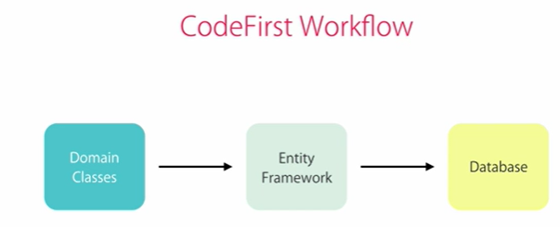

Code first migration:

Every changes we do in application we need to create a new migrations.

First step enable migrations:

Enable-Migrations

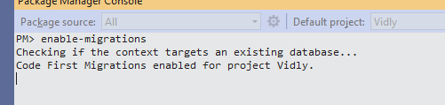

Add-migration ‘name of migration’

This will be the initial migration

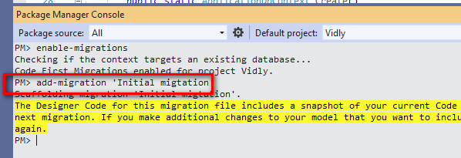

Open and see the migration file created we will find the scripts for updating db deleting relation s in db all other things

To override the existing migration

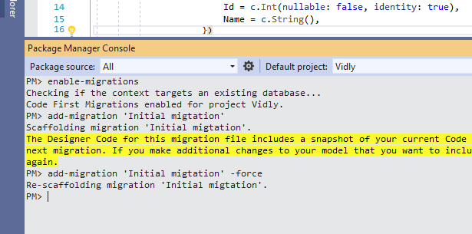

Updating changes to the DB

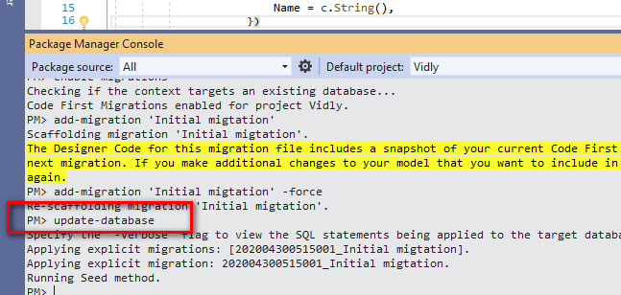

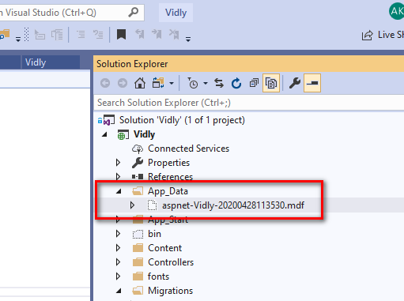

Add the mdf file in App_Data folder

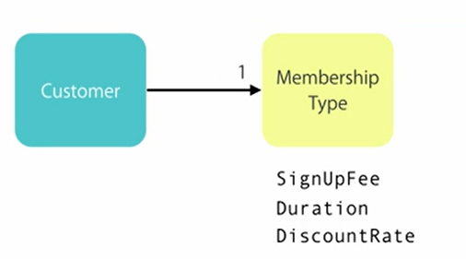

Always add small and simple migrations.

Seeding a database:

If any fixed table value always value should go from migration

Its also possible to populate table using migration

1. Add empty migration
2. Then write sql statement inside the up method of the migration

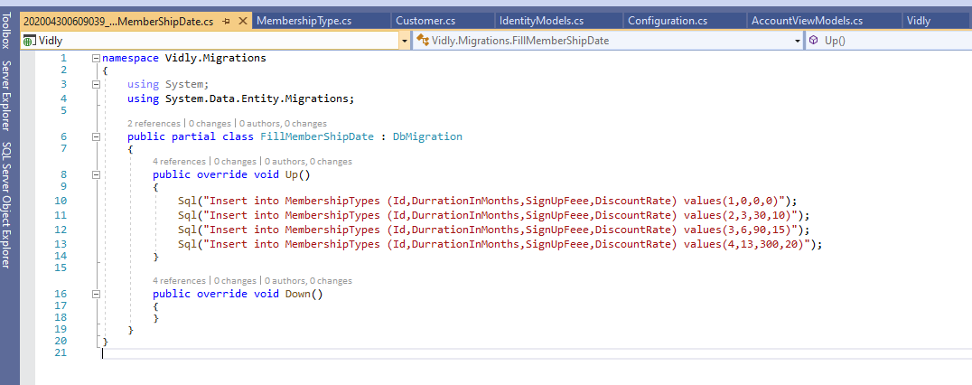

Then update the Db

Overriding the default conventions. Called data annotation

Why with this we can have constraints put on top of our columns.

Eger loading:

Using system.Data.Entity:

This will load the related entity along with the entity we are going to load.

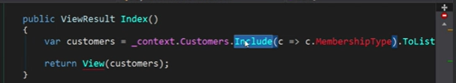

Saving data to Db

All the method which involves data save operation or edit operation should post the data back to the server so We need to decorate the method with HttpPost attribute.

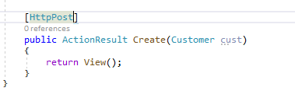

We have try update model method used to updated the model value with the model read from the view that we need to. But this will update everything including the ids.

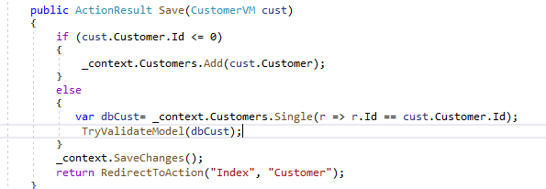

So its always better to use member wise copy or have some mapper implementation that does the mapping process.

Data annotation

Using these ewe can perform validation on the data these are default validators we can as well have some custom validators.

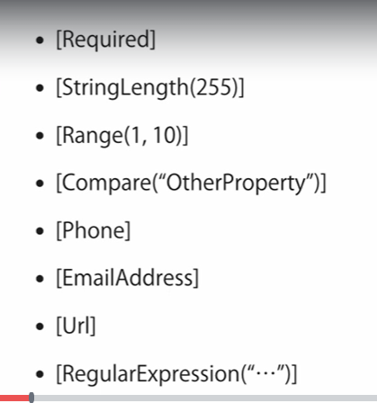

Validation via Attribute on top of the model fields

Or custom validation that is done with the help of the custom validators.

Use ValidationAttribute class as parent override IValida methodsx

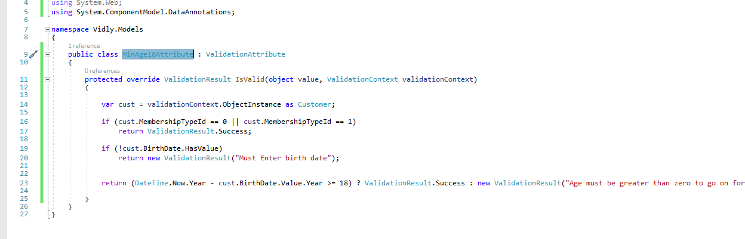

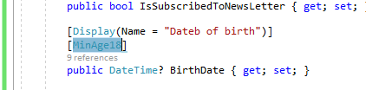

Ignore validation for field

ModelState.Remove(“field name”);

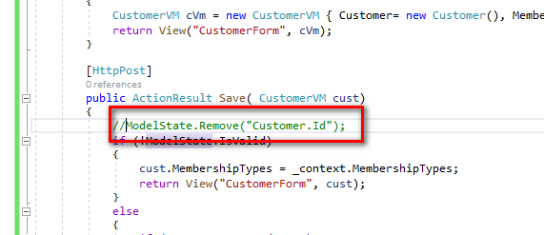

Validation on the client side is achieved with the help of Jquery validation plugin to be used by the MVC framework

We need to refer validation script in the respective URL

This will perform the validation of only the standard attributes added on top of the fields. Not for the custom attributes.

Anti forgery token:

Used to avoid CSRF attack malicious user will pretend as a trusted user and try to get access to the application resources.

Rest service: basically data can be returned as raw.

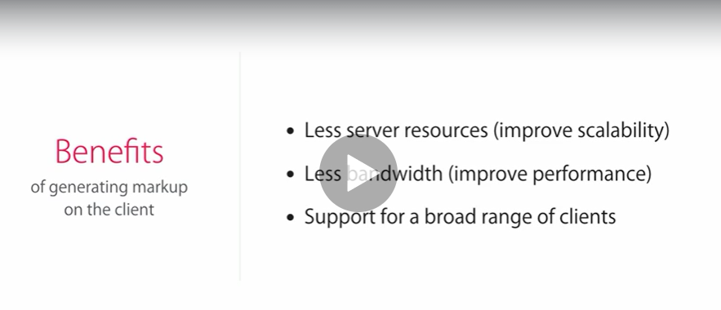

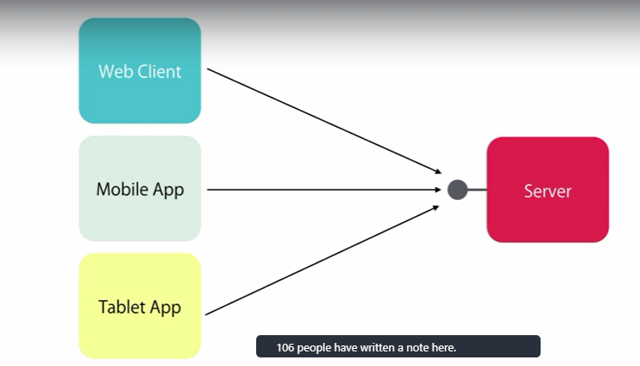



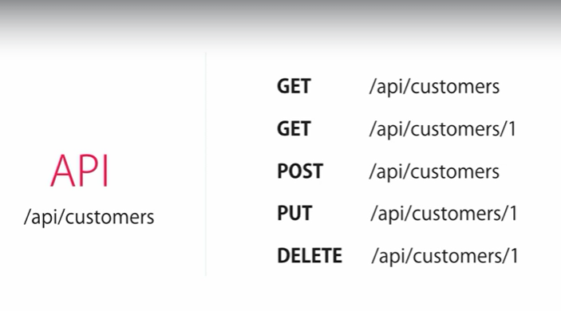

Post from postman

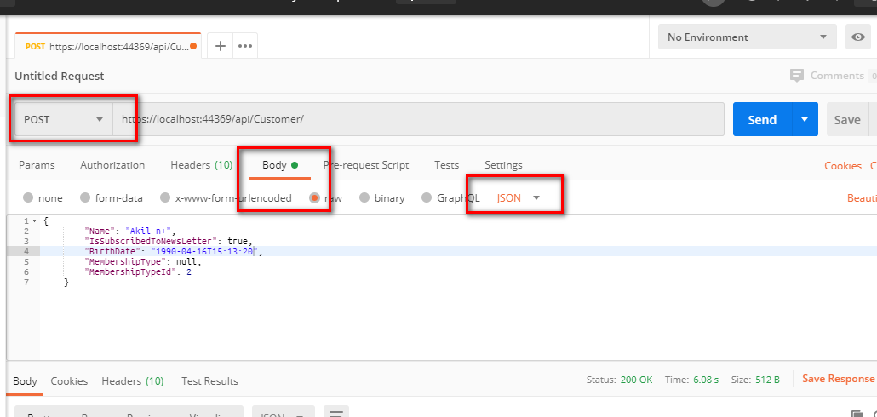

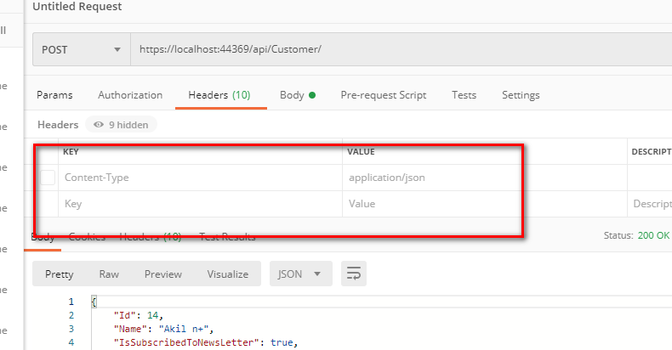

DTO (data transfer object)

Plain class object that is used to exchange the data between the client and the server.

Issue with the pure domain class (model) if the public service and Domain objects are tightly bound to each other then changes to the model will affect the controllers. To avoid we use DTO.

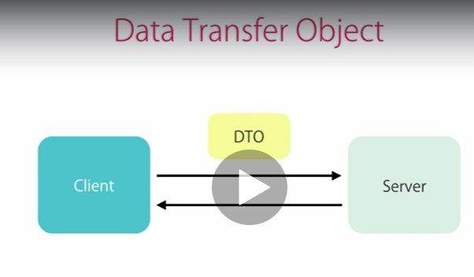

Api should not receive or send the Domain objects directly

Use package auto mapper to map between the two dissimilar class objects where in it maps the matching objects values by making use of reflections.

For this install the automapper.

Pm> install-package automapper -version:4.1

Create mapping profil.

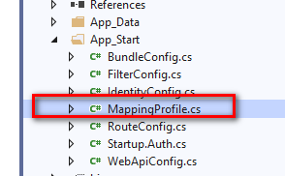

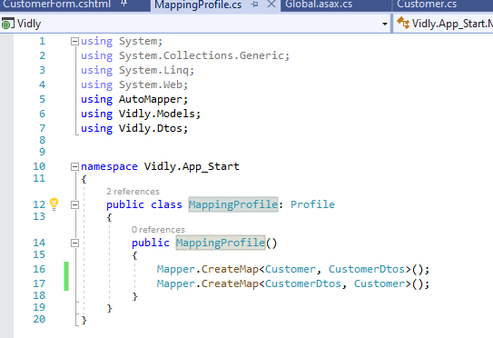

Call this in global.exe file

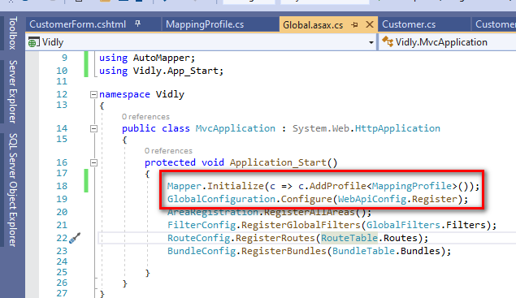

Using mappers:

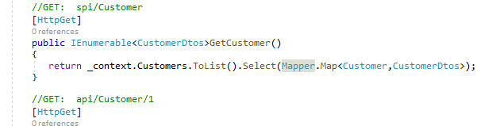

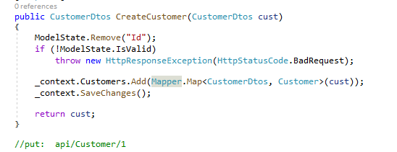

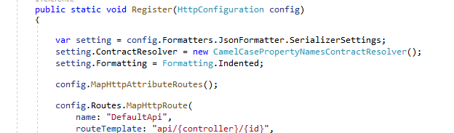

Boot box

Bootstrap frame work to build interactive popup boxes.

Pm>install-package bootbox -version:4.3.0

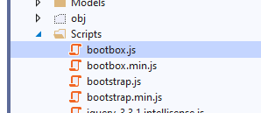

Unlike our normal confirm boot box doesn’t return Boolean value

Call bak function with the result.

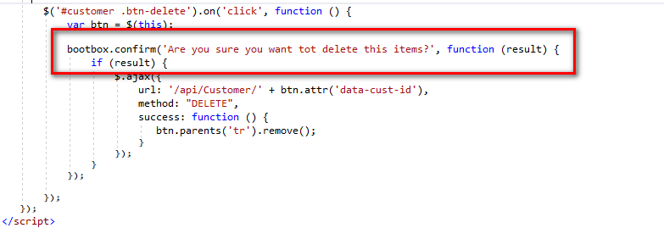

Adding filter to the selector to implement the single instance of the script in memory.

Hook the script to data table and on click of the button filter fire the script.

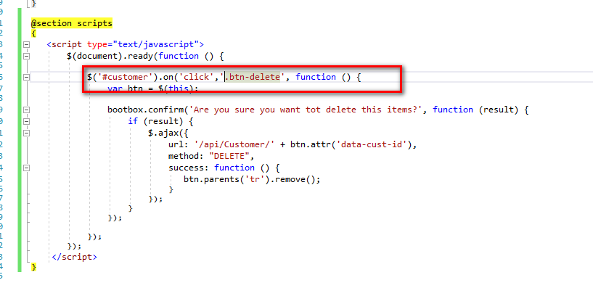

Datatabe plugin

Jquery.Datatables

PM> install-package jquery.datatables -version:1.10.11

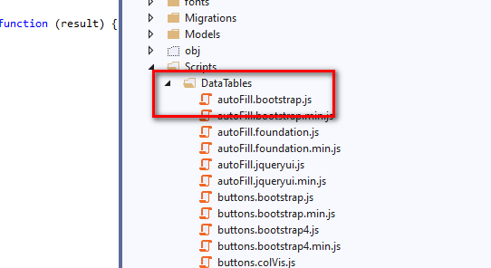

On install you get new folder with data table of script extensions for data table

We need to include style and script files in bundle related to the Datatable

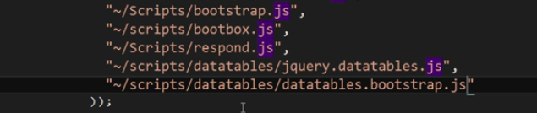

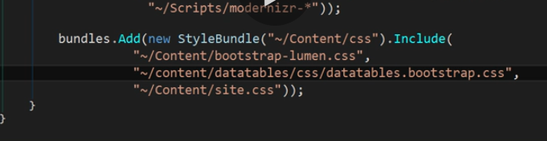

Define table structure:

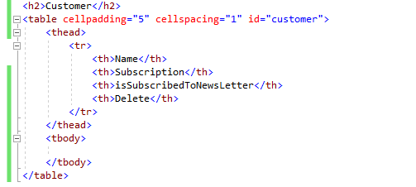

Map table to datatable methods and store the temp data table object

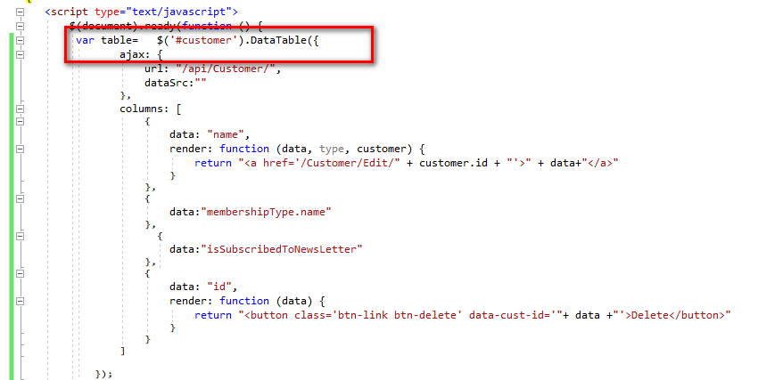

Remove the row from the data table draw the table back

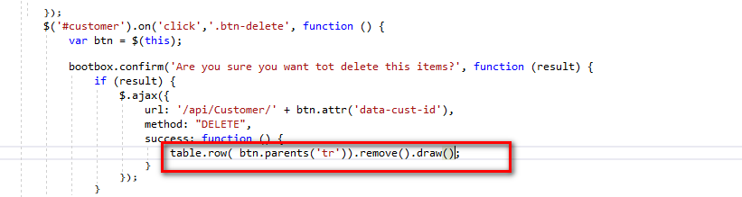

Asp.net Identity framework:

Authentication and authorization

Asp.net identity:

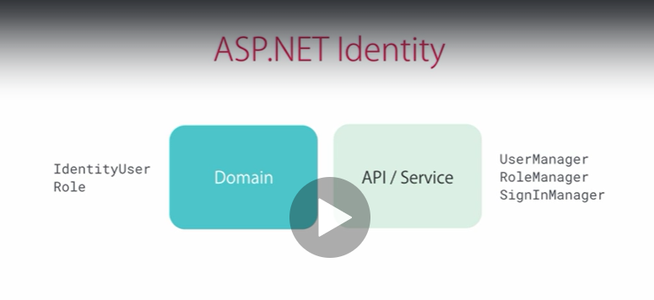

Db operation

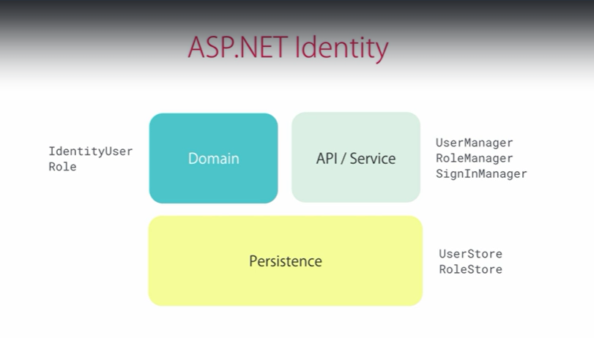

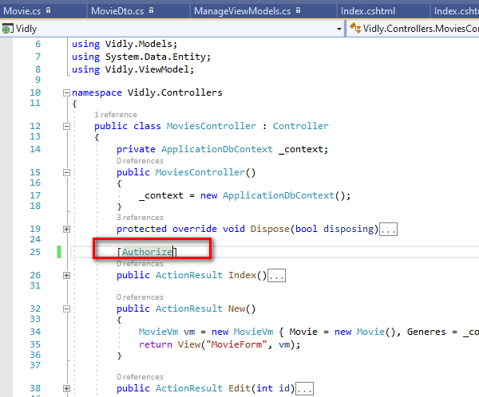

Action level

Controller level

Global level:

Register it under the global filters in Application_start

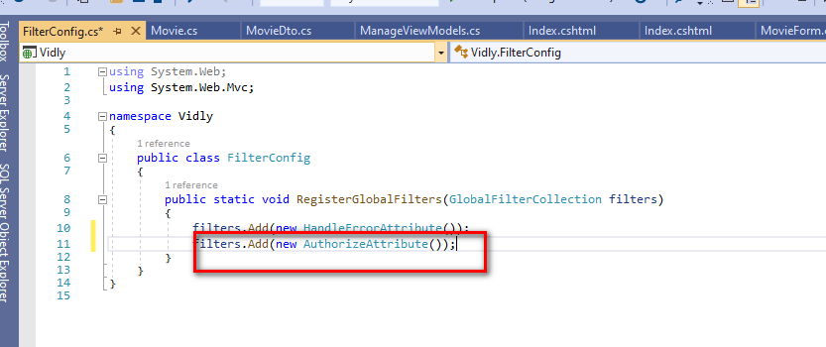

Role filter on action mthod

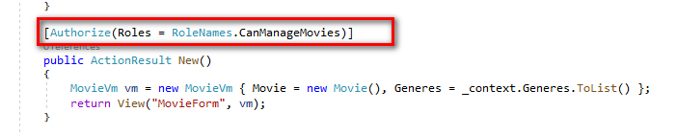

User role check for display of view

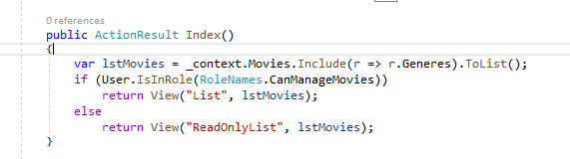

Adding profile data:

All Social site that provides authentication (external authentication) to other application uses a protocol called OAuth

Open Authorisation

So how it works:

For this first register your application with Facebook. Face book will give secret token king of user name and password to be used in our application

So when the new user try to register to your application using face book . our application will be authenticated with face book using our application

To provide more security alwas communicate using HTTPs so that request is always encrypted.

1. User try to register via facebook form our application. Application key and secret will be send to face book and user enters his credentials
2. Once the user is authenticated by facebook.

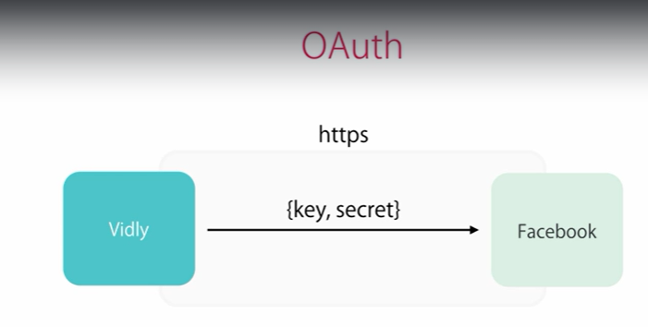

1. Authorization code will be sent to our application by Facebook saying the user is authorized to register to your application

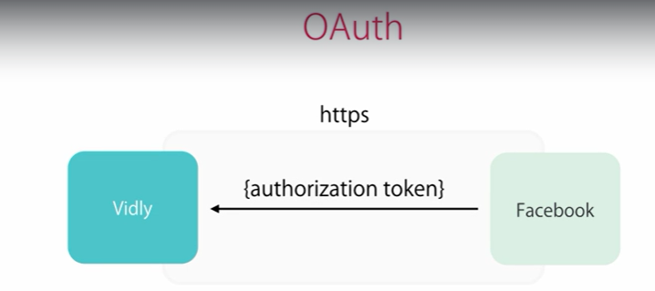

1. Then our application will resend this authorization token, application key, secret back to the FB to check if this token is actually sent by him to access the information

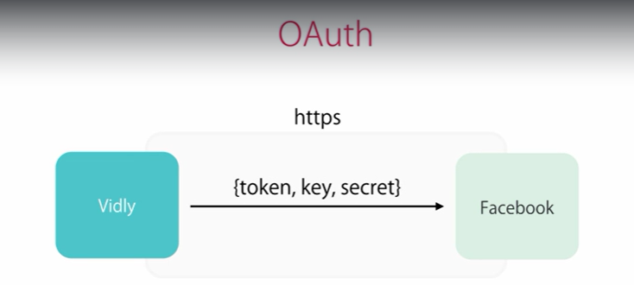

1. Once the FB validates this token it sends the accessToken to the application using which he can access the information from Fb.

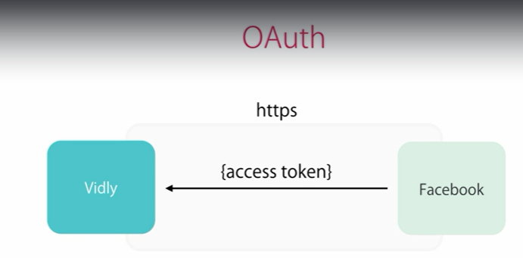

Enable Application for SSL

Register application in facebook to get application id and secret key

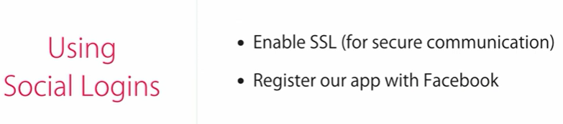

Registering application to SSL:

Select project > Click on to F4> enable project for SSL

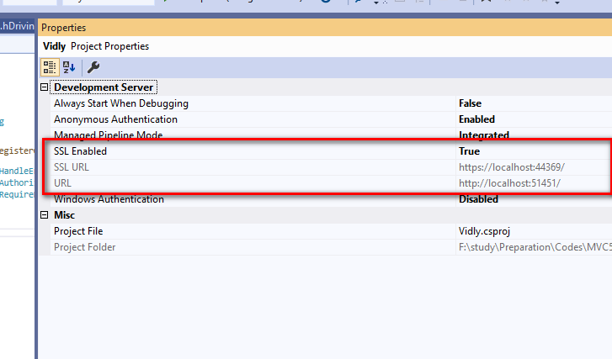

Right click o project > properties> web menu

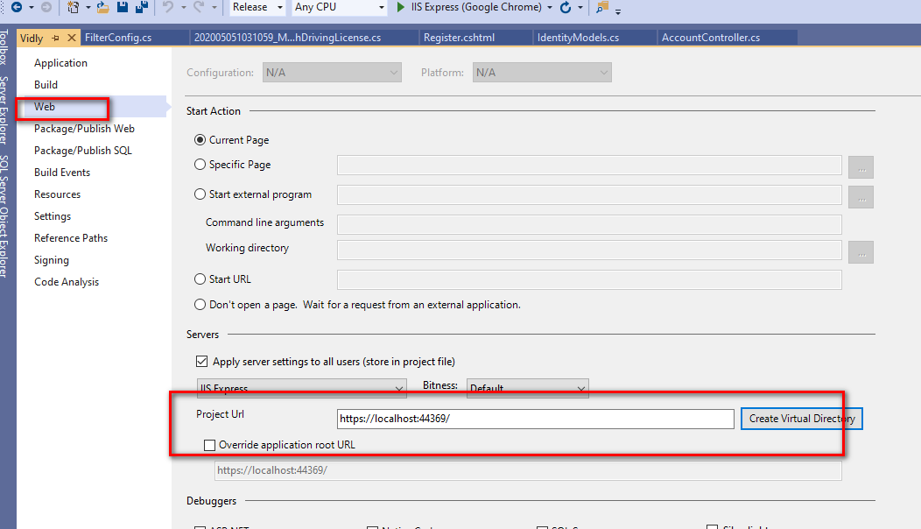

Copy the SSL url

Now log in to the developer.facebook.com website

Register yourself as developer which is free of cost

Now App new aap

Go to app dashboard

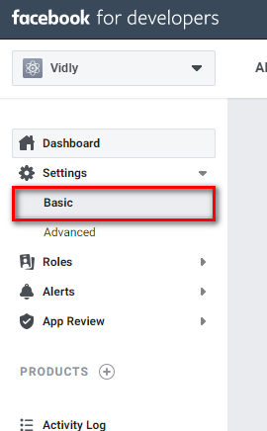

Make some basic setting where we can get the information related to the App id

App secret

And we need to register our application SSL url

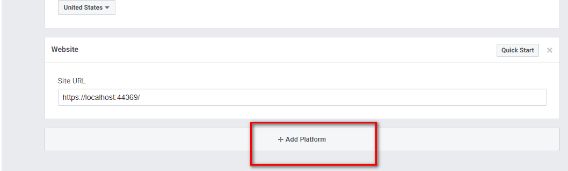

Performance optimization:

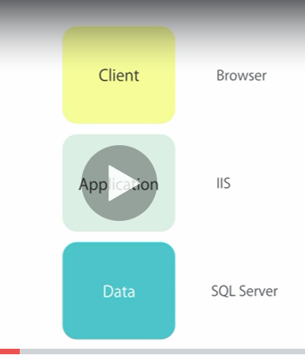

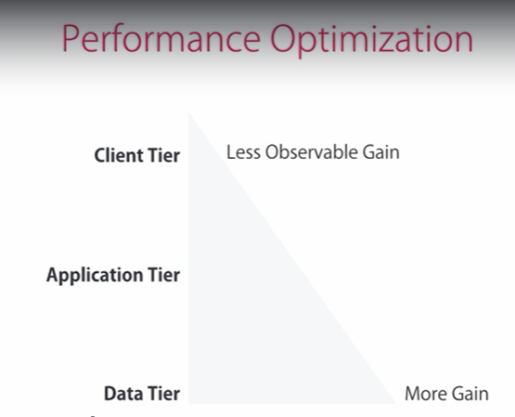  
Data tire:

Primary key

Relation

Indexing

Tool to analyse application performance using glimpse tool

1. Install these packages in your application

Pm> Install-package glimpse.mvc5

Pm> install-package glimpse.ef6

Lazy load

Eager load

N+1 issue:

Issue where one query is executed to get all parent records. But Once each extra query executed for the N customer to load lazy load data.

Eager load: Load parent and related entity data at one go. SO no additional query is run

Lazy load: Initially parent data will be loaded and child data will be loaded only when call to the actual member form the child is called

TO make lazy load define property as virtual

Load application virtual path like below:

<https://localhost:44369/glimpse.axd>

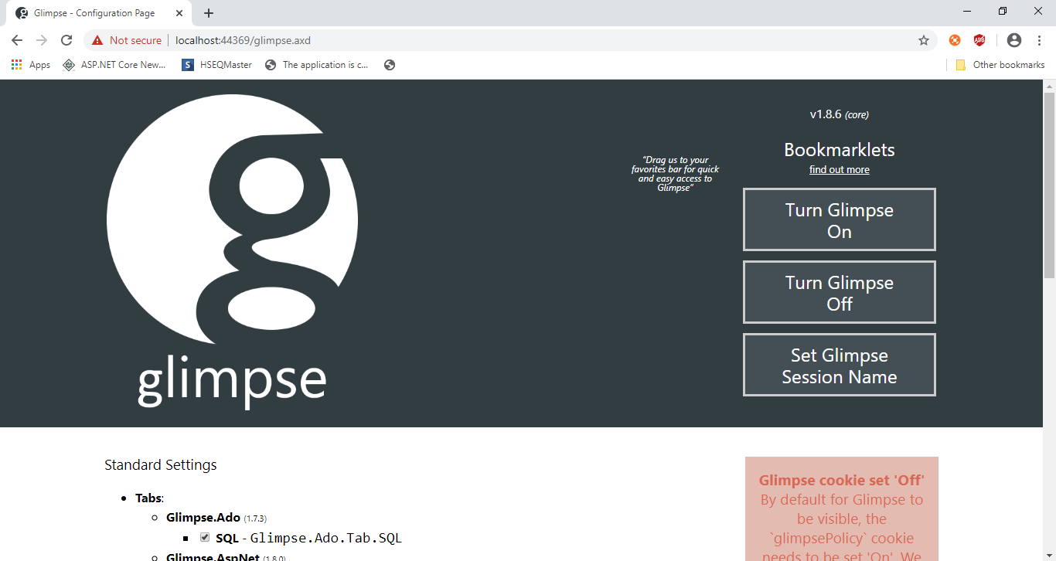

From this screen turn on the glimpse for your application

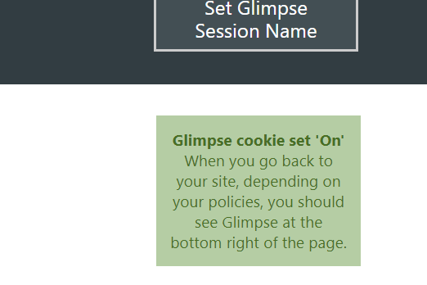

You will get a glimpse bar at the bottom of your screen that will give. The glimpses of your application when it runs.

Using this we get complete glimpse of the current request and also other requests. We can literally trace the request

**Outputcache:**

Decorate the controller action with

Outputcache attribute

Duration: indicates time for which the output has to be cached

Location: Ouptupucache location client, server

VaryByparam indicate to maintain separate version for each value in the parameter list

Nostore: true, false indicate o not store the cache

Used to cache the entire page output from the request

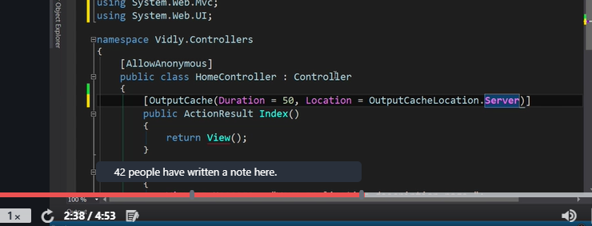

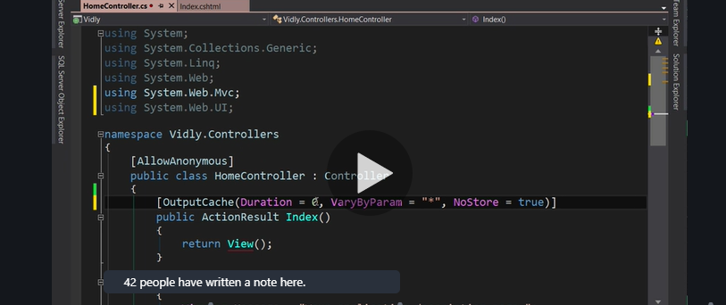

Disabling out put cache from being displaying the staled data

**DataCache:**

its always good to cache the data that do not changes frequently in application. Don’t cache too many data because it will have impact on the application memery.

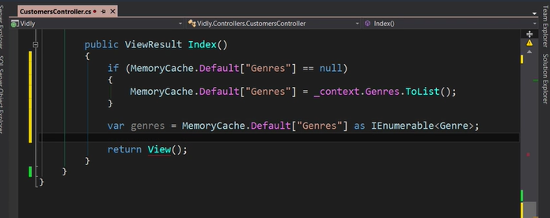

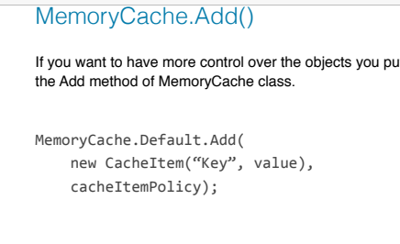

2nd parameter used is cacheItemPolicy used to set expiration time and call back when the item is removed from the cache.

Asyn/Await:

Request comes > thread assigned to process this request> Now in process path > process waiting for Some memory bound operation so thread will be idle.

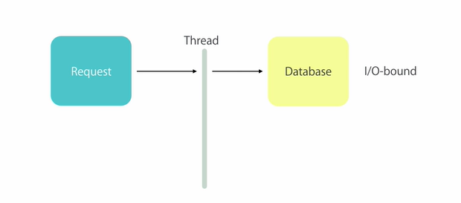

Because server may have limited resources or the thread to serve the request. This will lead failure of the application because no thread is available to serve the request

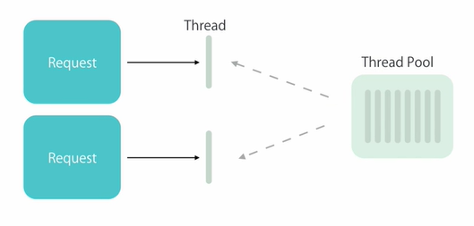

Use async/await with which we can increase the availability of the server by releasing the thread which is waiting long for the thread from the thread pool.

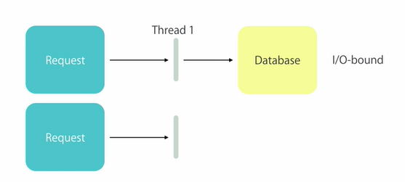

Release mode build:

All debug releated stuffs will be removed as a result smaller assembly will be deployed.

Disabling the session:

Piece of memory allocated to each user on the server. More user more space used on the server

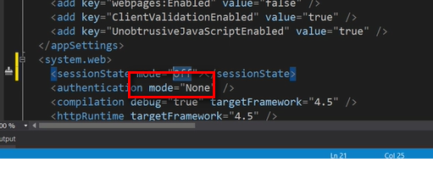

So every request should be a stateless request.

Client side optimization:

Put all the client resources inside the bundle

Put script bundle file near the end of body tag

Building an App End to End

Adding the movie rental channel where in person goes to the

New plugin with this we can load the data as we type into some control king of suggestion on type of the control

Pm> install-package twitter.typeahead

Typeahead.bundel.js

Bloodhound is a suggestion engine behind the type ahead library and heart of the type ahead library.

Encapsulate all business logic for auto compilation such as calling backend Api and caching result

datumTokenizer: responsible for taking the data and converting them into bunch of data token

Eg:

 datumTokenizer: Bloodhound.tokenizers.obj.whitespace('value'),

take value property from the data and tokenize them separated by space

queryTokenizer:

queryTokenizer: Bloodhound.tokenizers.whitespace,

Again a function that convert query into bunch of tokens

Prefetch: provide data on initialization this will eliminate the additional call

Remote responsible for the Api called to get search data

 remote: {

                   url: '../data/films/queries/%QUERY.json',

                   wildcard: '%QUERY'

                   }

Here wildcard data is used along with URL this indicates on search data from text box basically search token will be copied to the wild card to be passed to the

Say I want to send a notifications in our application So we need to use another jquery plugin called toaster

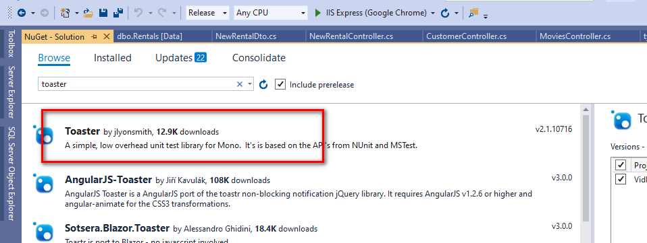

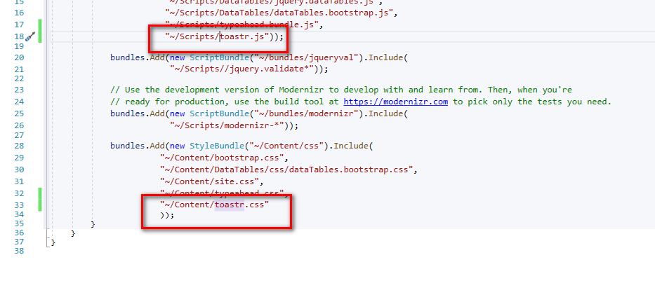

Validation on the page using jquery.

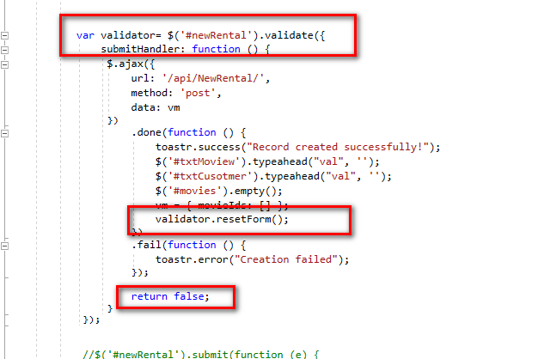

Use jquery validator method

Handel submitHandler

This will return the validator object used for resetting form

Return false for avoiding the normal form submit behaviour

TO add customer validator to the form we can do following

Define custom validator using jquery instance.



Use control data attribute to link the rule

Data-rule-addCustomer=”true”

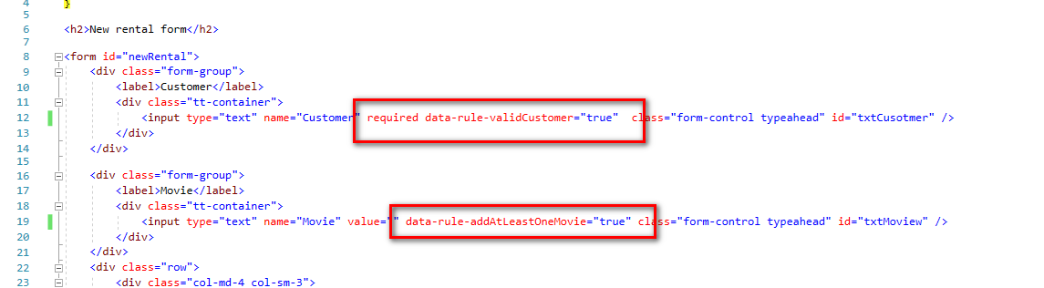

Deployment.

Publish application code in release mode using the file system option selected

Select the folder to publish and then hit publish.

Publish db Scripts:

Update -database -script -SourceMigration:’name from where the migration is not updated’

Build configuration:

Create new configuration type using configuration manager

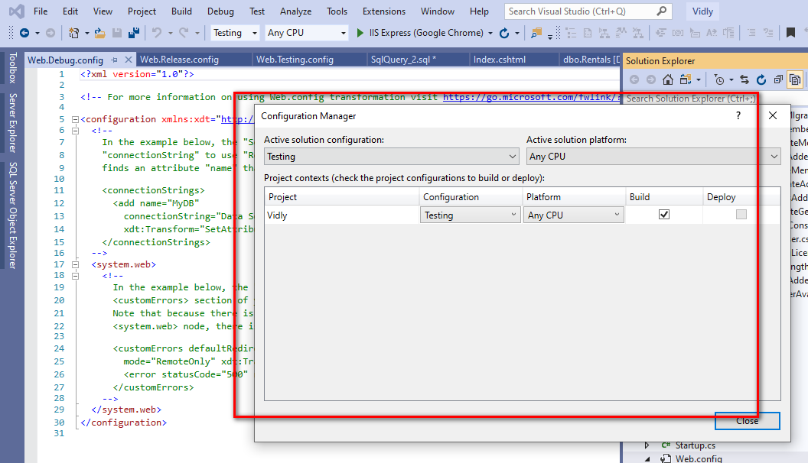

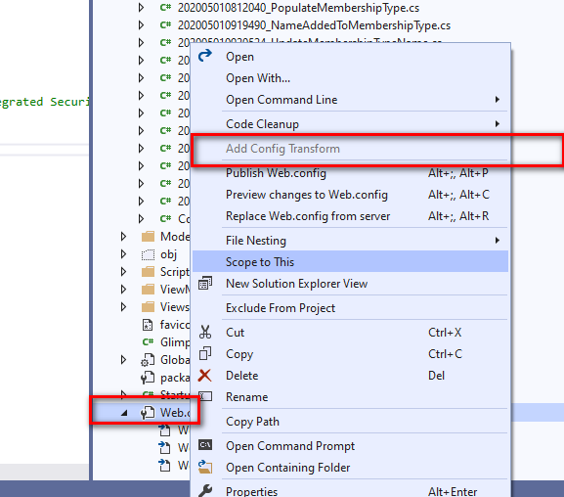

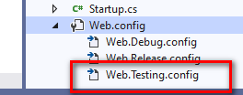

So in every configuration file we need to have the settings which basically we need to override

Right click on to the configuration file and preview the file

Protecting the configuration files.

Most of the time as a part of configuration file we save the user name and password values to secret information about the services we us in the application.

Approach one:

Create separate file with extension as test.Config (config called as configuration file)

Then use this file inside the config source

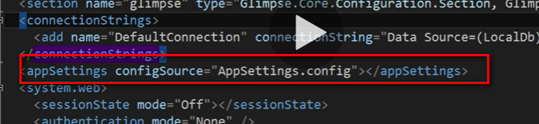

Next encrypt the section of the config file which you want to keep it protected.

Use Aspnet_regiss

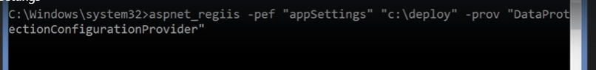

Decryption:

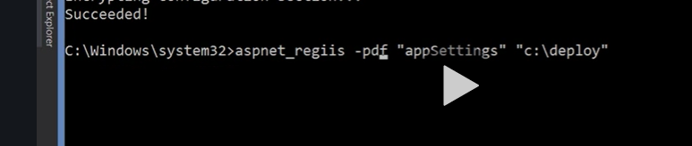

Handel unhandled exception:

Here we need to define error section

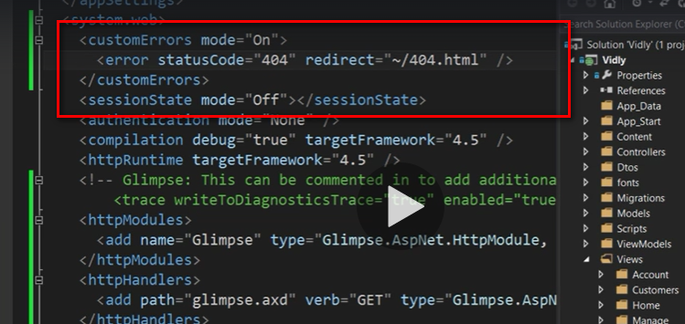

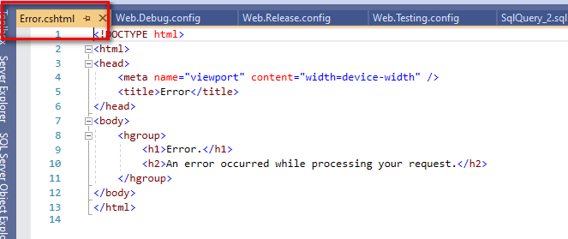

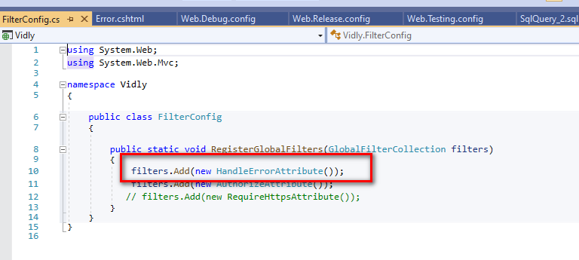

Handling http error from the server

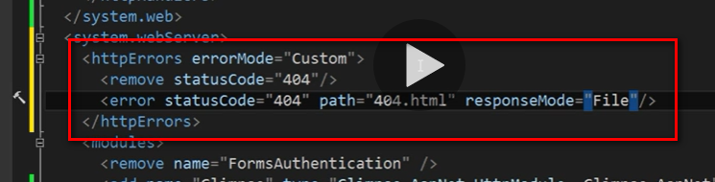

Logging unhandled exception

This can be oden with the help of famous package called elmah

Elmah= error login module and handler.

Elmah.axd urls we need to laod to see the exception logging info

**OWIN katana**

Qwin is specification and katana is a framework

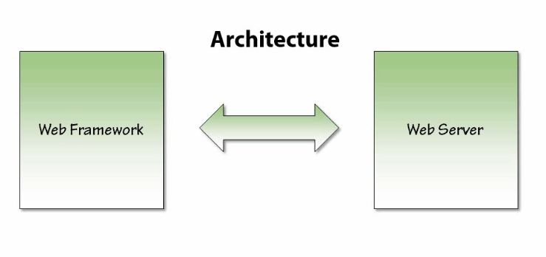

Main goal of katana is to make your eb application lighter and load only those components and library help full in loading the app. Don’t load everything to the memory.

Modular software

Owin provides that specification to build the modular software.

OWIN: (open Web server interface)

Kata is implementation of MS open standard called OWIN.

Basically is defines set of specification when in web server and Apis communicate with each other in a decoupled way.

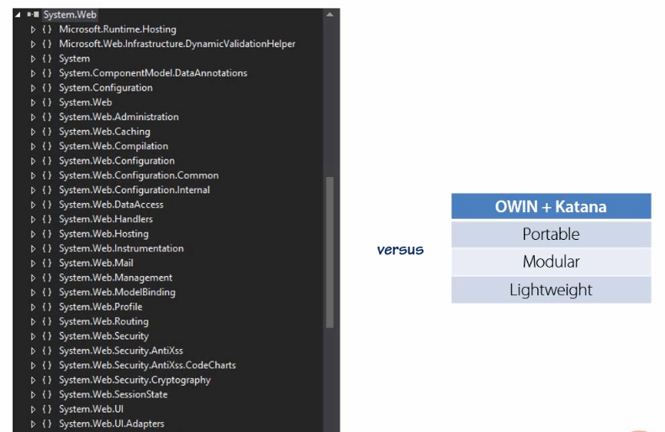

Console App uses kata and listen to HTTP request:

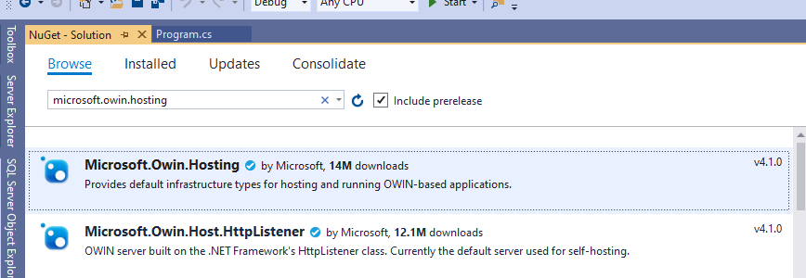

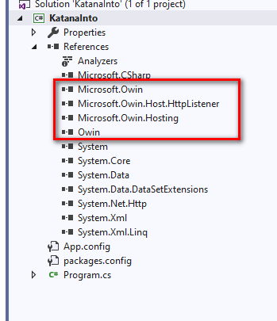

Core katana components

HttpListner interact with the Os list to port to get http message

Now we have components that helps you to build a console applications web server.

All katana application implemented using Owin specification has start-up class where in we configure the application

Add addition features and start-up pages to your app

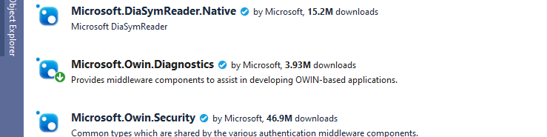

**AppFunc:**

